**CS 2302 Data Structures**

**Fall 2019**

**Lab Report #4**

Due: October 22nd, 2019

Professor: Olac Fuentes

TA: Anindita Nath

**Introduction**

For this lab, we were asked to implement a binary search tree (BST) and a B-Tree in order to store words and their embeddings in such a way that the embeddings can be used to compare two given words. For this lab, it is key to remember the properties of a BST and a B-Tree since they are required for all exercises. The main objective of this lab is to compare the running times of these two data structures in order to determine the most efficient implementation to retrieve word embeddings and compare various pairs of words.

**Proposed Solution Design and Implementation**

**Operation #1 (BST implementation):**

For this operation, I created a *BST* class that contains all the necessary functions to build a proper BST that can be used to store words and their embeddings. In the *BST* class, I implemented a *buildBST(T, file)* function that builds the BST of word embeddings by reading a file that contains many words and their embeddings and retrieving each word along with its embedding. If the word starts with an alphabetic character, then the function creates a WordEmbedding object for that word and its embedding and inserts it into its proper place in the BST.

The *insert(T, newdata)* function used by the previous function is a modified version of the *insert(T, newdata)* originally provided by the professor. In this modified version, the function compares the values of the BST nodes by accessing the word in the WordEmbedding object that is stored in each node. That way, the function can traverse through the right path of the BST and insert each WordEmbedding object into its proper place.

In addition to these two functions, I implemented three additional functions that take advantage of the properties of the BST to perform their tasks. These three functions are the *search(T, word)*, *numNodes(T)*,and *height(T)* functions.

The *search(T, word)* function traverses through a certain path of the BST to return the node with the WordEmbedding object containing the word that matches with the searched word. If the searched word is not in the BST, the function returns None.

The *numNodes(T)* function traverses through the entire BST to count the number of nodes it contains. If the BST is empty, the function returns 0.

The *height(T)* function also traverses through the entire BST to determine its longest path, which corresponds to its height. If the BST is empty, the function returns -1.

In terms of query processing (i.e. the part of the lab where various pairs of words are compared with each other), the big-O running time of this operation is **O(log n)** because it does not traverse through the entire BST to find a specific word. Rather, it traverses a specific path along the BST, which is dictated by the word to be found in the BST.

**Operation #2 (B-Tree implementation):**

For this operation, I created a *B-Tree* class that contains all the necessary functions to build a proper B-Tree that can be used to store words and their embeddings. In the *BST* class, I implemented a *buildBTree(T, file)* function that builds the B-Tree of word embeddings by reading a file that contains many words and their embeddings and retrieving each word along with its embedding. If the word starts with an alphabetic character, then the function creates a WordEmbedding object for that word and its embedding and inserts it into its proper place in the B-Tree.

All the necessary functions to insert each WordEmbedding object into the B-Tree were provided by the professor. However, I modified a few of the functions in order to accommodate for the insertion of WordEmbedding objects. These modified functions include the *findChild(T, k)* and *insertLeaf(T, i)* functions.

I modified the *findChild(T, k)* function so that it can compare two different WordEmbedding objects in the B-Tree by accessing each object’s word. That way, it is possible to determine the proper place of the WordEmbedding object *k* in the B-Tree by determining the value *c* of the position of a child node, such that the WordEmbedding object must be in the subtree *T.child[c]*.

I modified the *insertLeaf(T, i)* function so that it can sort the data in each node of the B-Tree. In this lab, the data is a list of WordEmbedding objects that can be sorted by modifying the *sort()* function of the list of data in each B-Tree node.

In addition to these two functions, I modified the *search(T, k*) function so that it returns the WordEmbedding object from the node where a word *k* is found in the B-Tree. If that word *k* is not in the B-Tree, the function returns None. To do this, I implemented a second version of the *findChild(T, k)* function that helps search for a word by comparing it to the word of all WordEmbedding objects in each node of the B-Tree and determining the value *c* of the position of a child node, such that the word must be in the subtree *T.child[c]*.

Additionally, I implemented two additional functions that take advantage of the properties of the B-Tree to perform their tasks. These two functions are the *numNodes(T)*,and *height(T)* functions.

The *numNodes(T)* function traverse through the entire B-Tree to count the number of nodes it contains. The function starts the node counter at 1, and it returns that value if it encounters a leaf node.

The *height(T)* function traverses from the root node to a single leaf node in the B-Tree to calculate its height. If the function encounters a leaf node, it returns 0.

In terms of query processing, the big-O running time of this operation is **O(n log n)** because it traverses a specific path along the B-Tree, which is dictated by the word to be found in the B-Tree, yet it traverses through the data of the node where that word is found in order to find its matching WordEmbedding object.

For both operations, I implemented a *WordEmbedding* class that has four functions to find the similarity between two words by using the cosine distance formula: sim(w0, w1) = e0 · e1 / |e0||e1|, where e0 · e1 is the dot product of the embeddings of the two words and |e0| and |e1| are the magnitudes of the embeddings. Two of these functions apply to the BST, and the other two apply to the B-Tree. Furthermore, each pair of functions has two separate implementations, one that reads a text file of paired words and the other that takes words from the user.

In the main file, I implemented a program that gives the user the option to choose their tree implementation. If the user chooses the B-Tree, then they will be prompted to enter the maximum number of items in each of the tree’s nodes. Additionally, the user is prompted to read a text file of paired words or enter two words in order to compare words. Once all selections have been made, the program builds the corresponding tree and displays its stats, which include its number of nodes and its height. Additionally, it displays the paired words along with their numerical similarity value. Lastly, it displays the running times for constructing the tree and processing the query.

**Experimental Results**

**Operation #1:**

For this operation, I will test text files of sizes 50, 100, 150, and 200, each of which contains randomly generated pairs of words separated by a space.

Case 1: Size of text file = 50

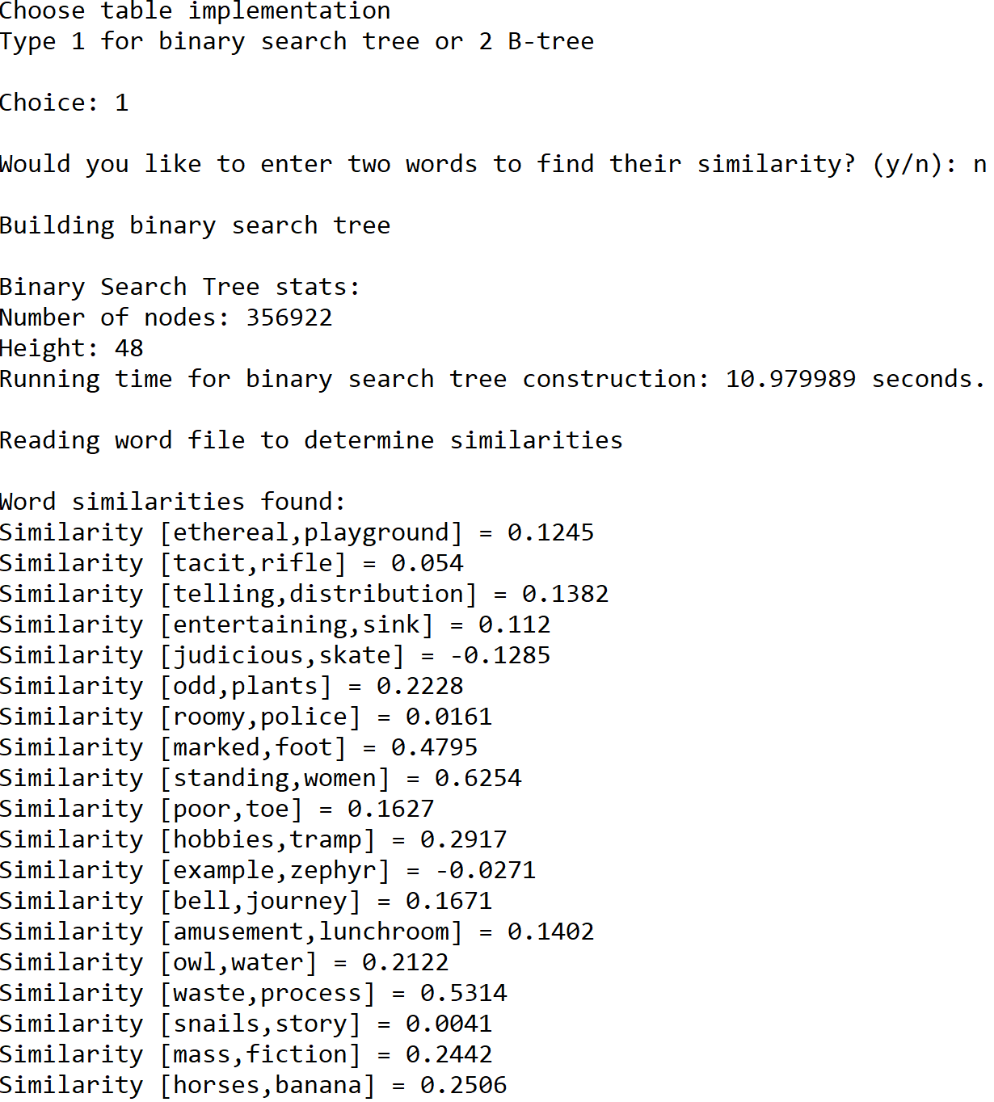

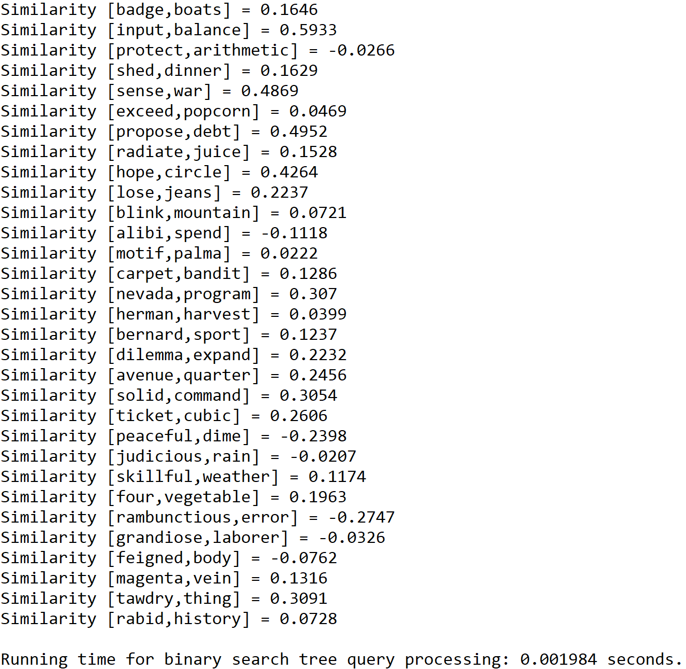

Case 2: Size of text file = 100

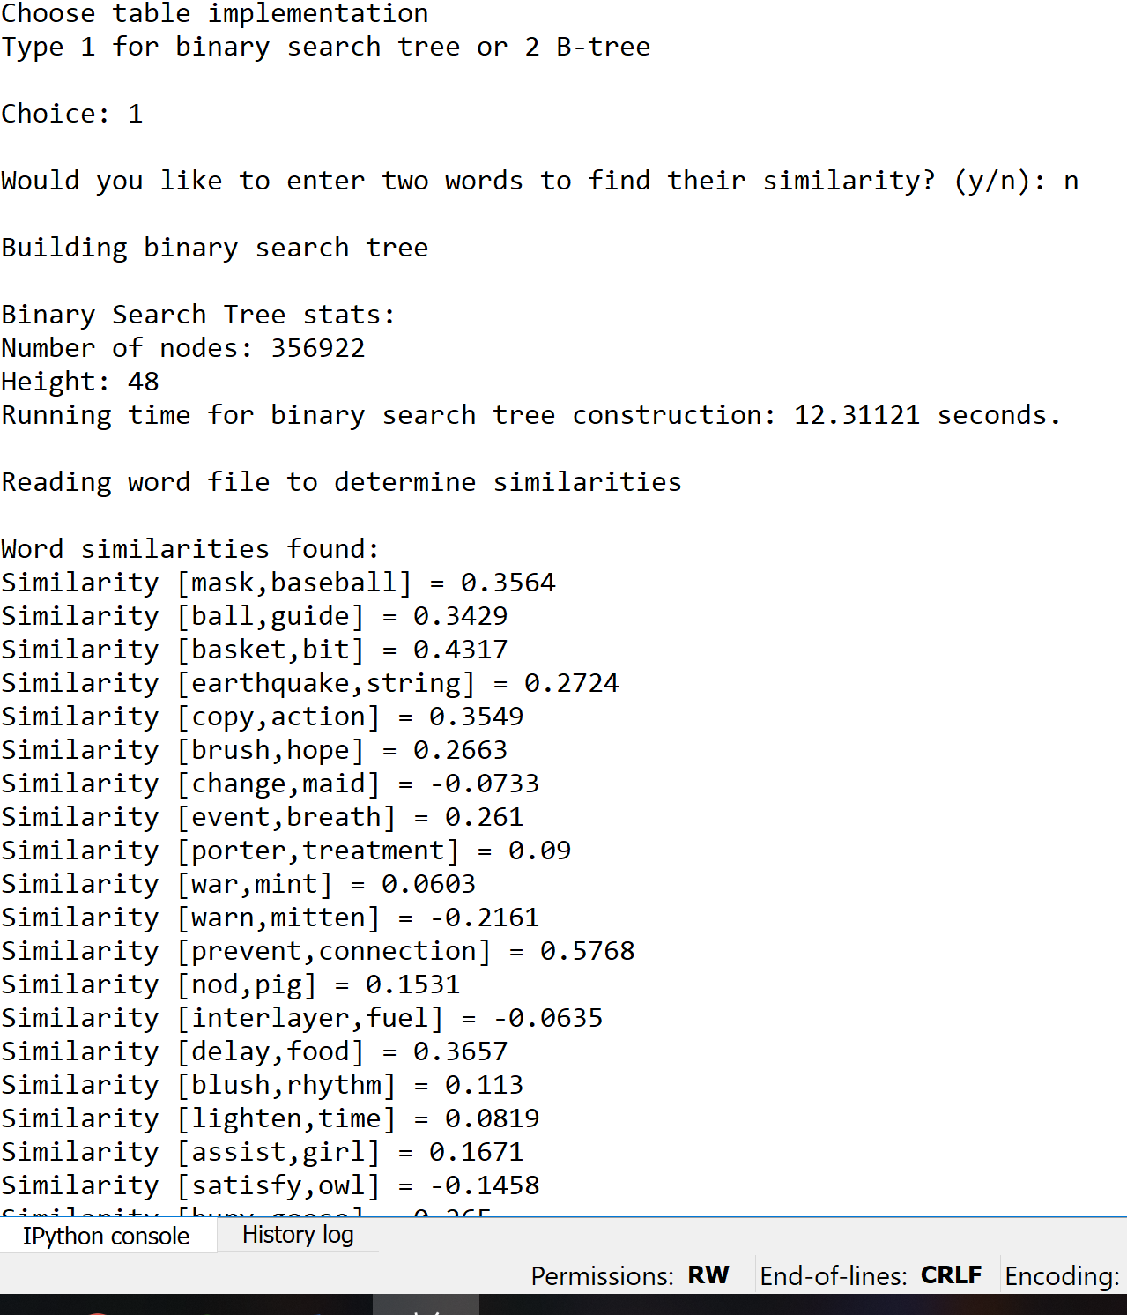

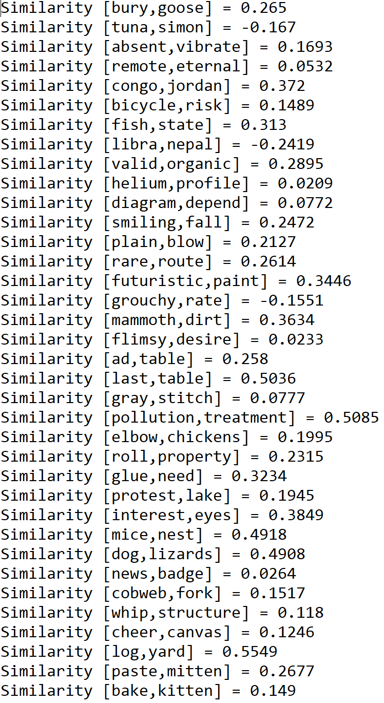

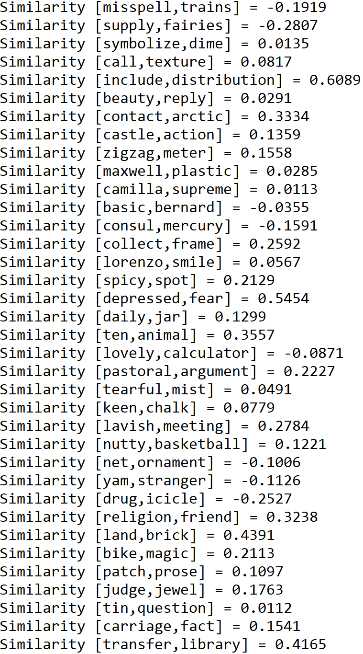

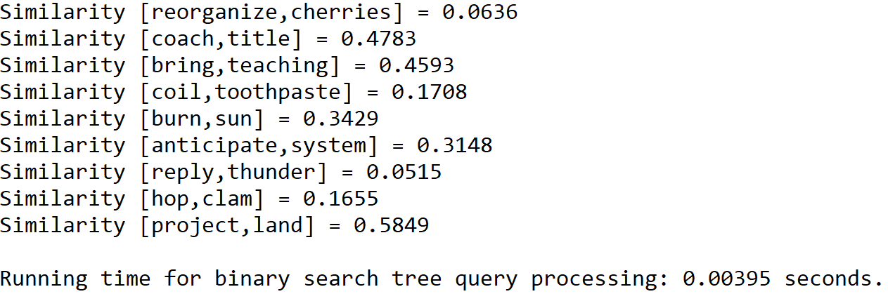

Case 3: Size of text file = 150

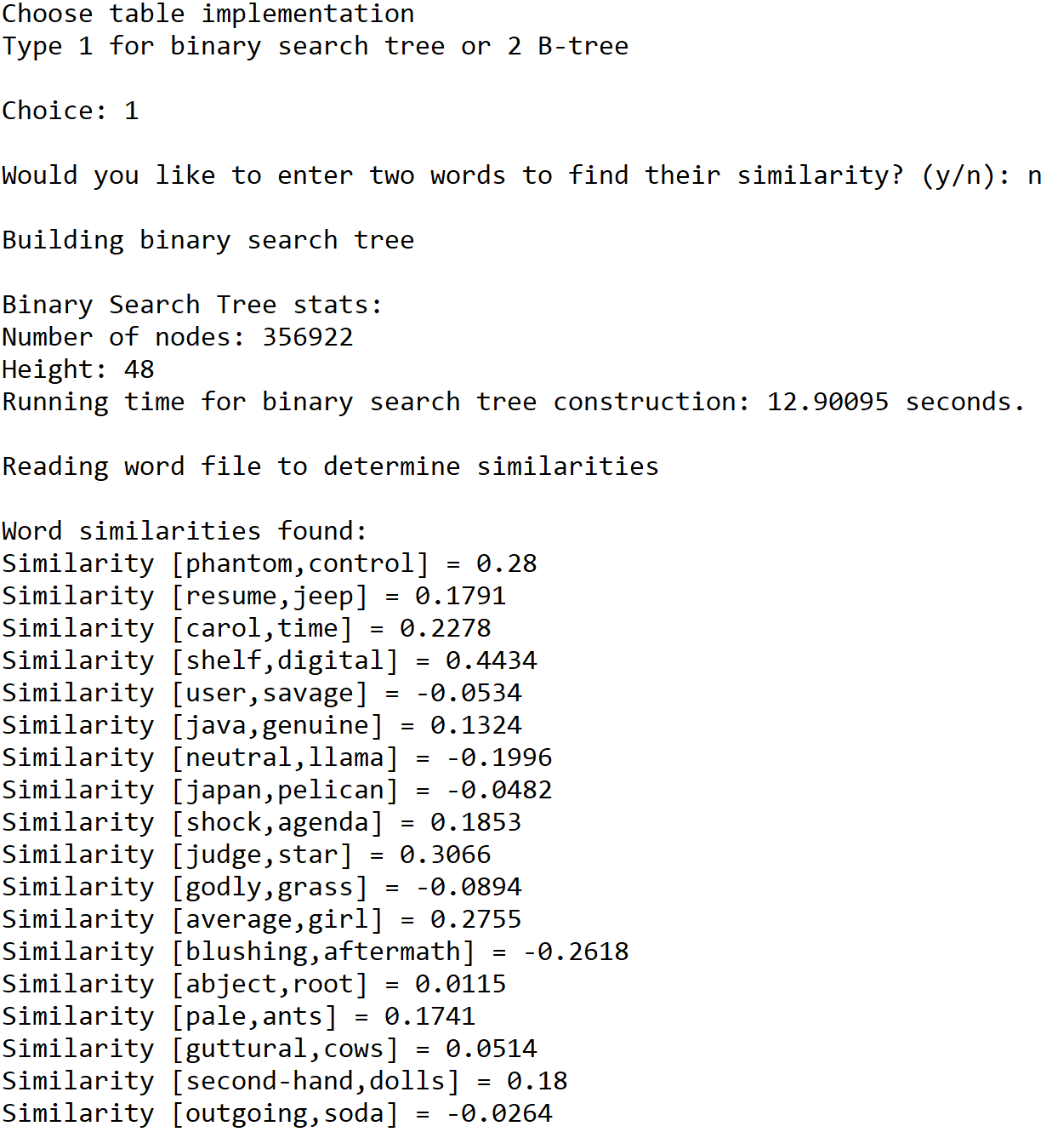

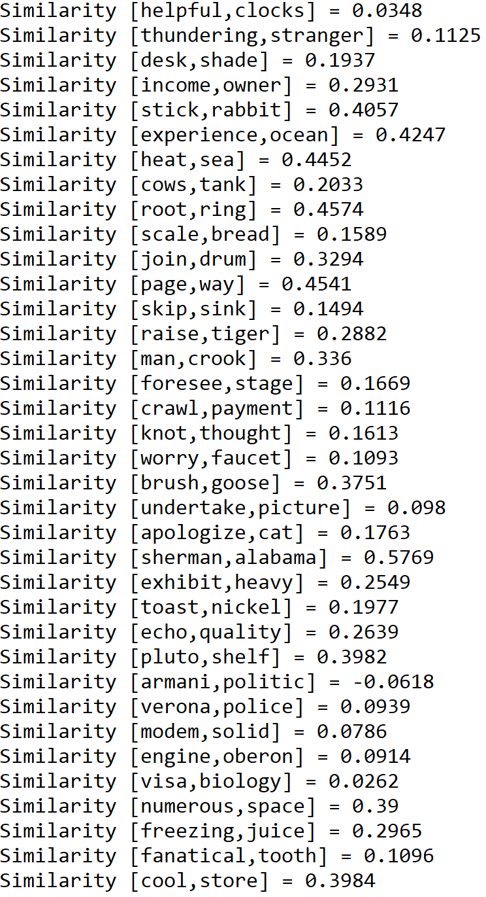

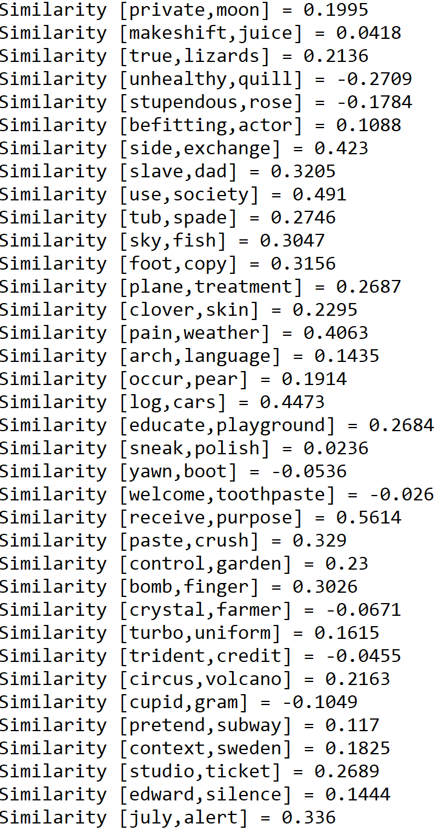

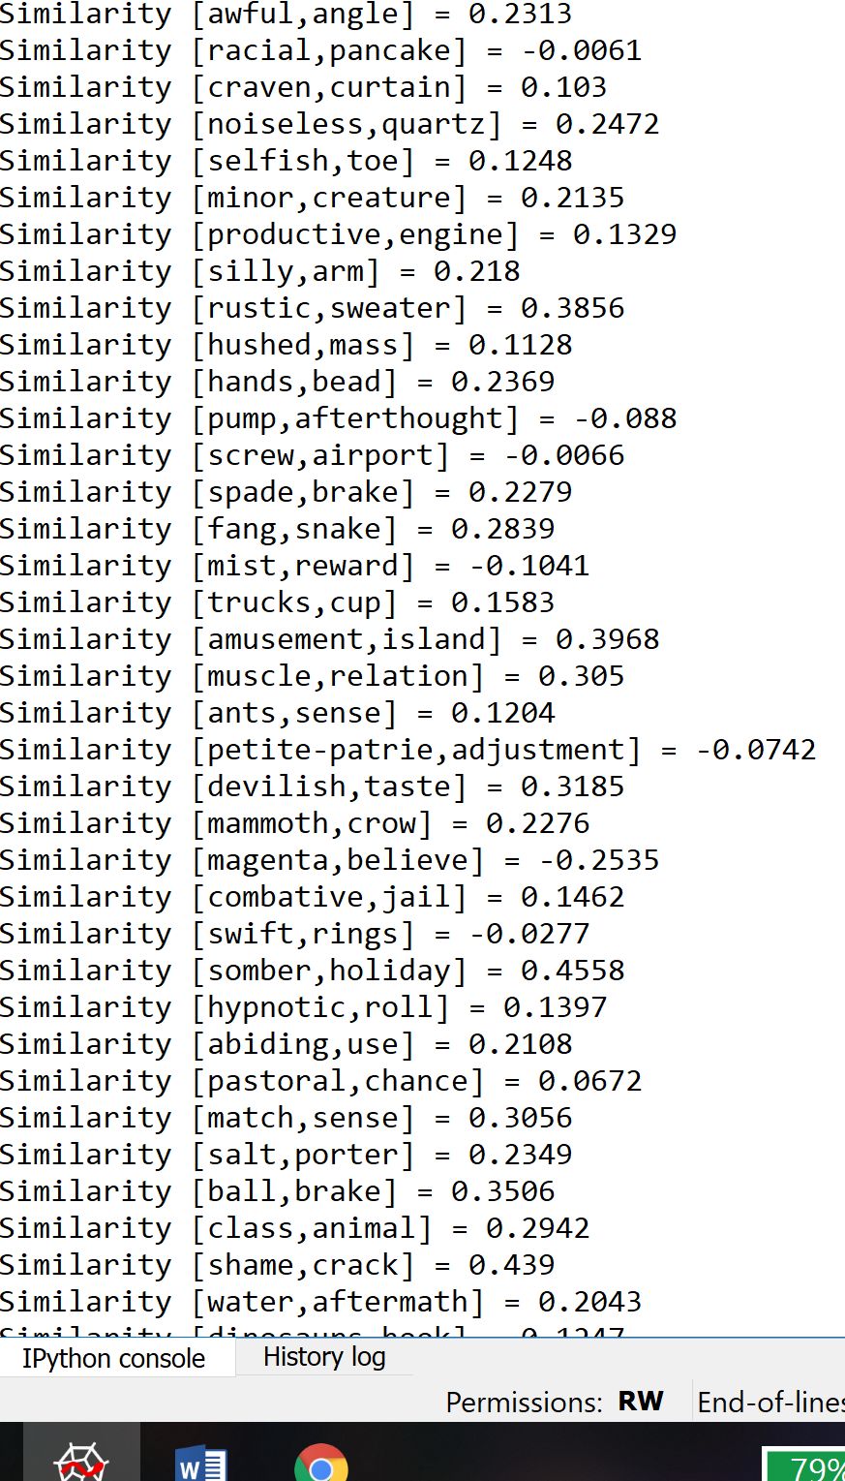

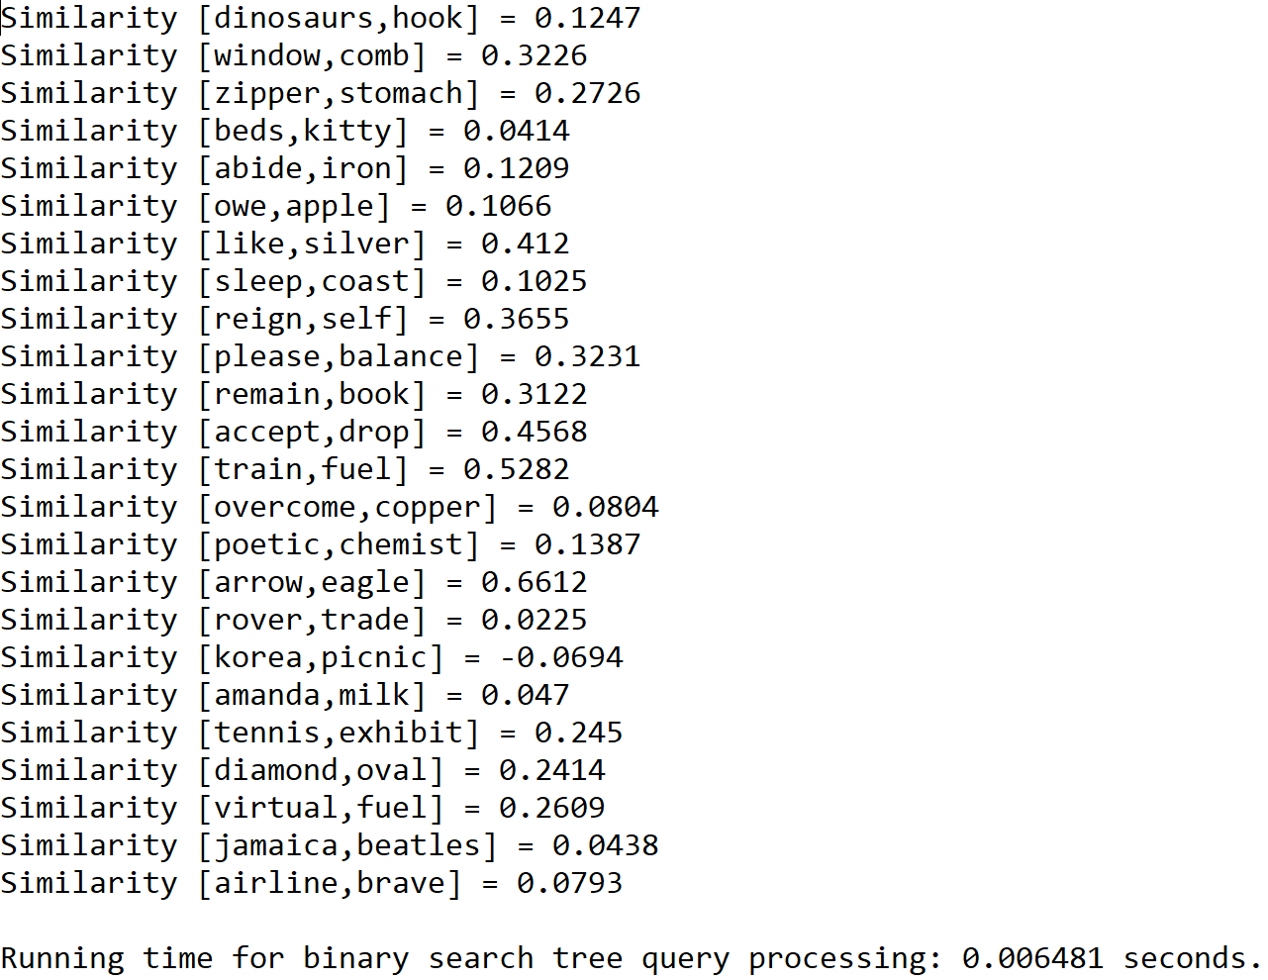

Case 4: Size of text file = 200

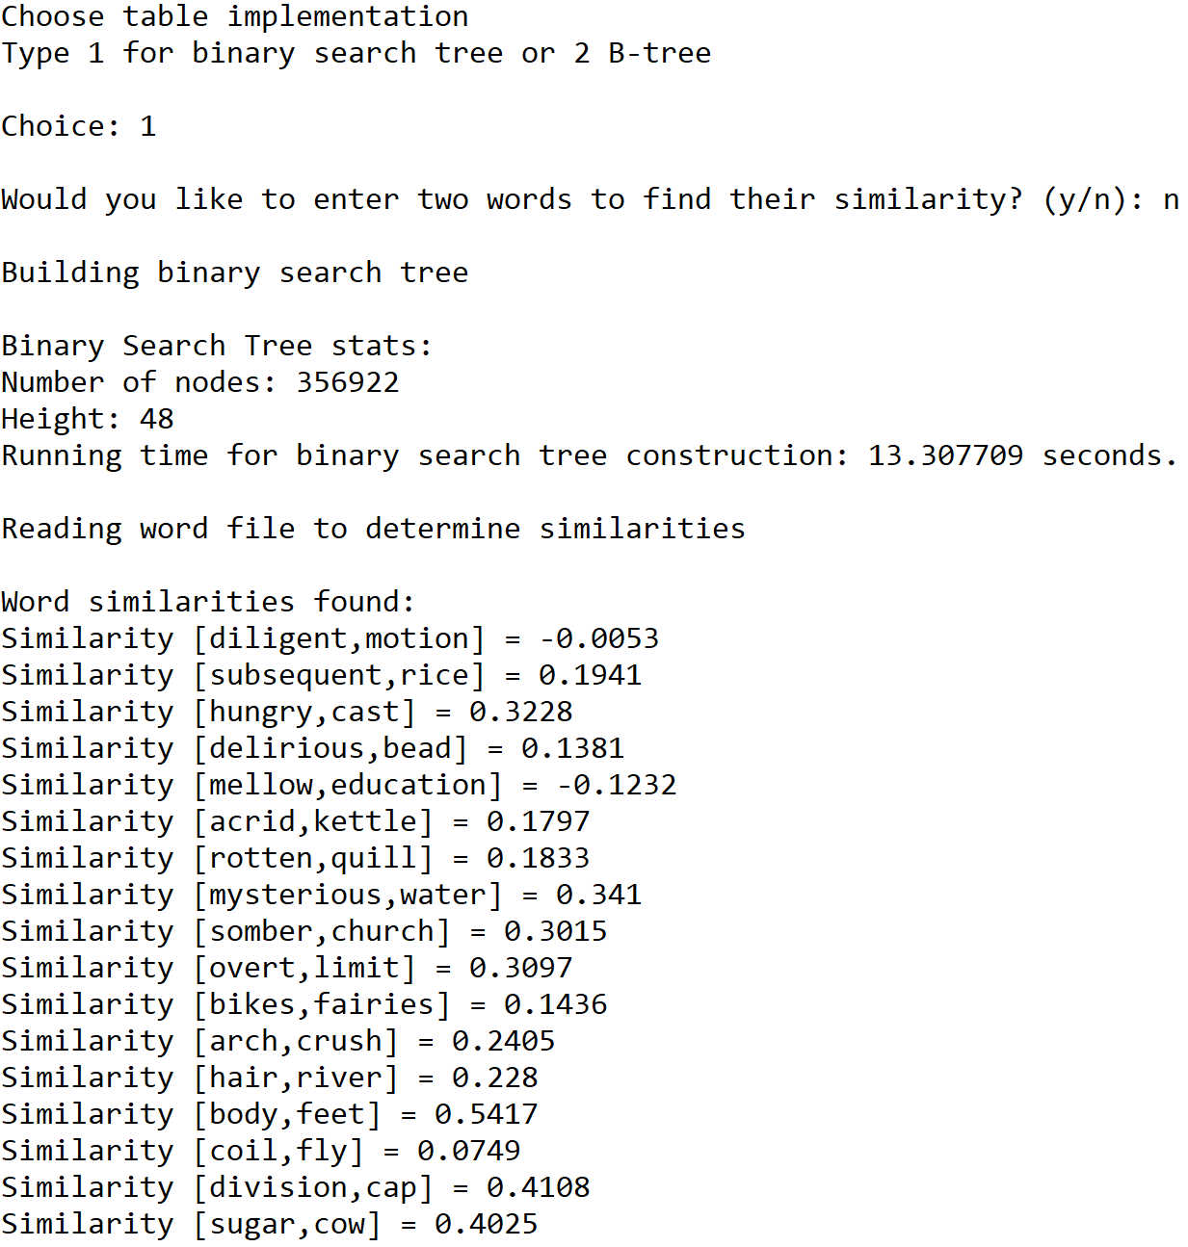

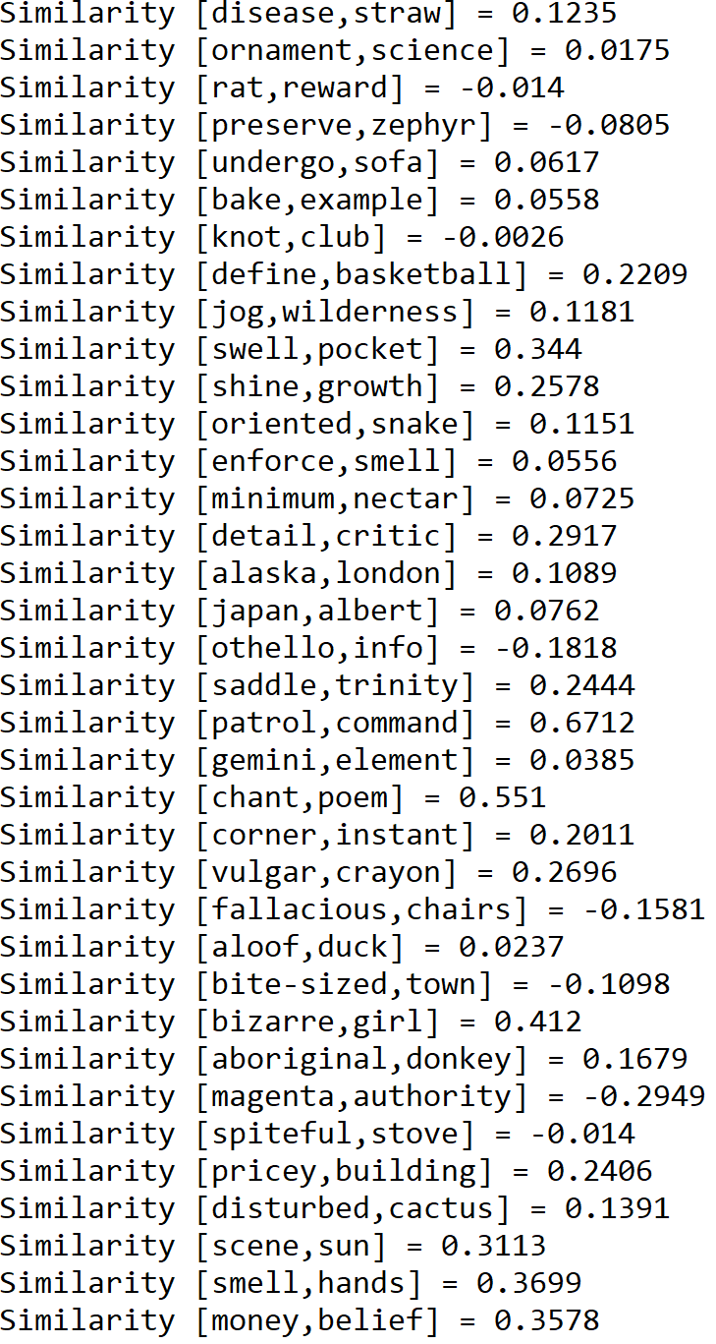

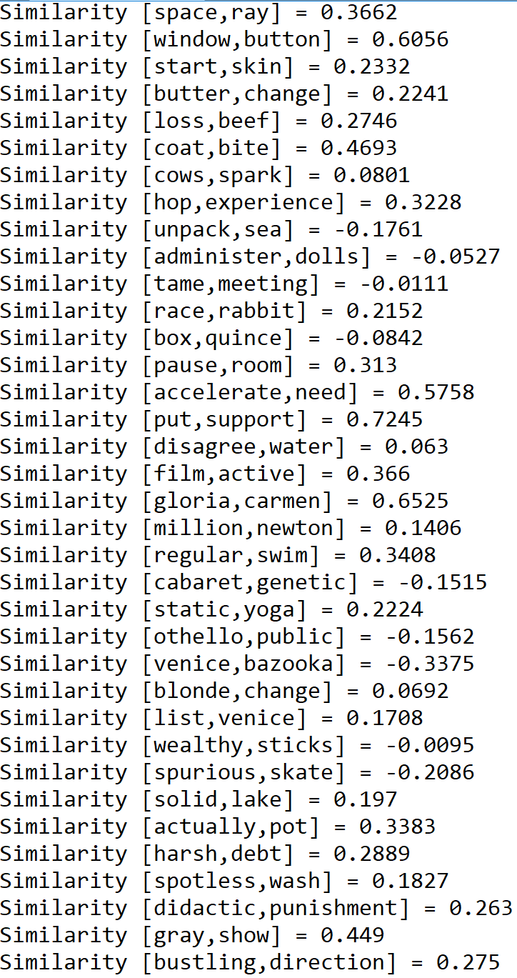

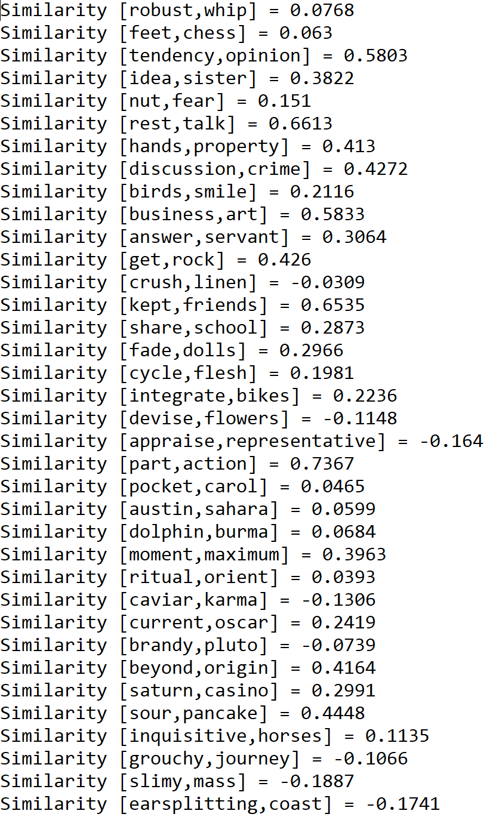

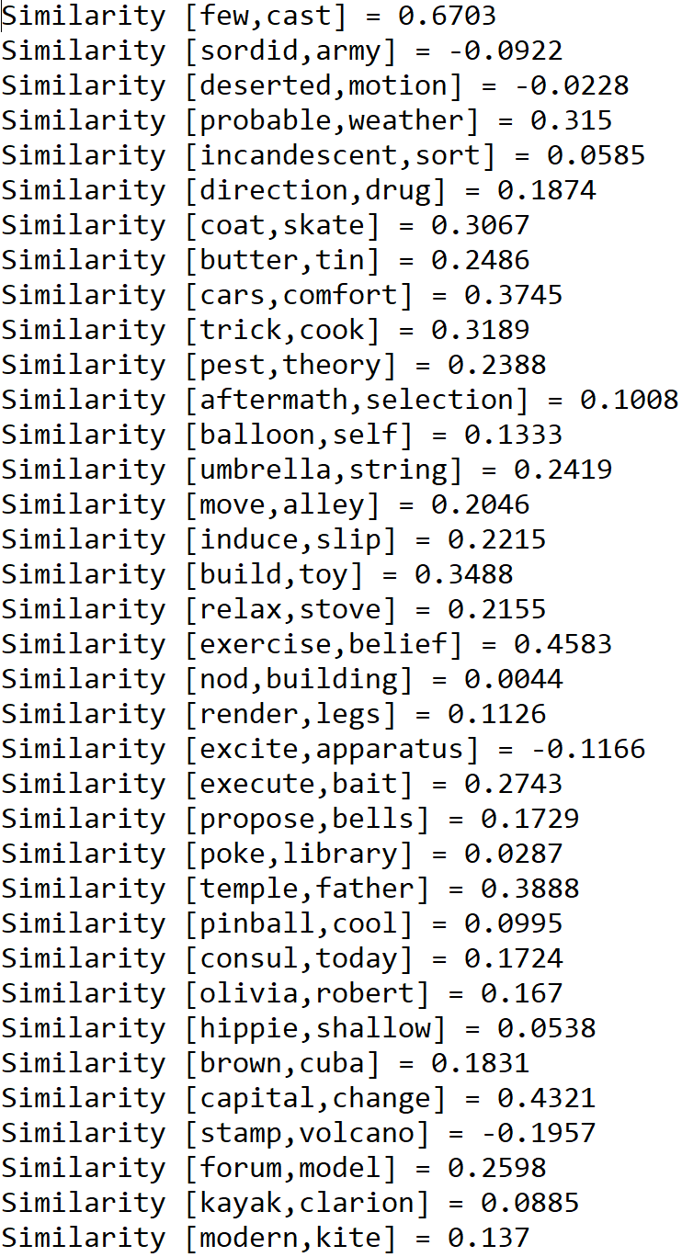

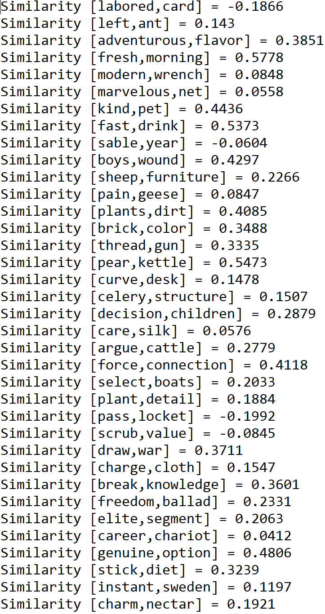

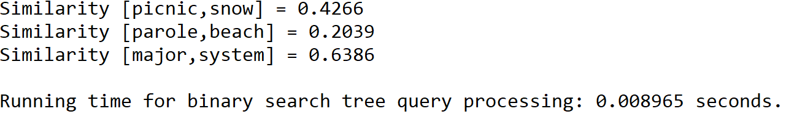

**Operation #2:**

For this operation, I will test text files of sizes 50, 100, 150, and 200, each of which contains randomly generated pairs of words separated by a space. Additionally, I will test for the effects of the choice of parameters of the B-Tree by entering 5, 10, 15, and 20 as the maximum number of items in each node of the tree.

Case 1: Size of the text file = 50, maximum number of items in node = 5

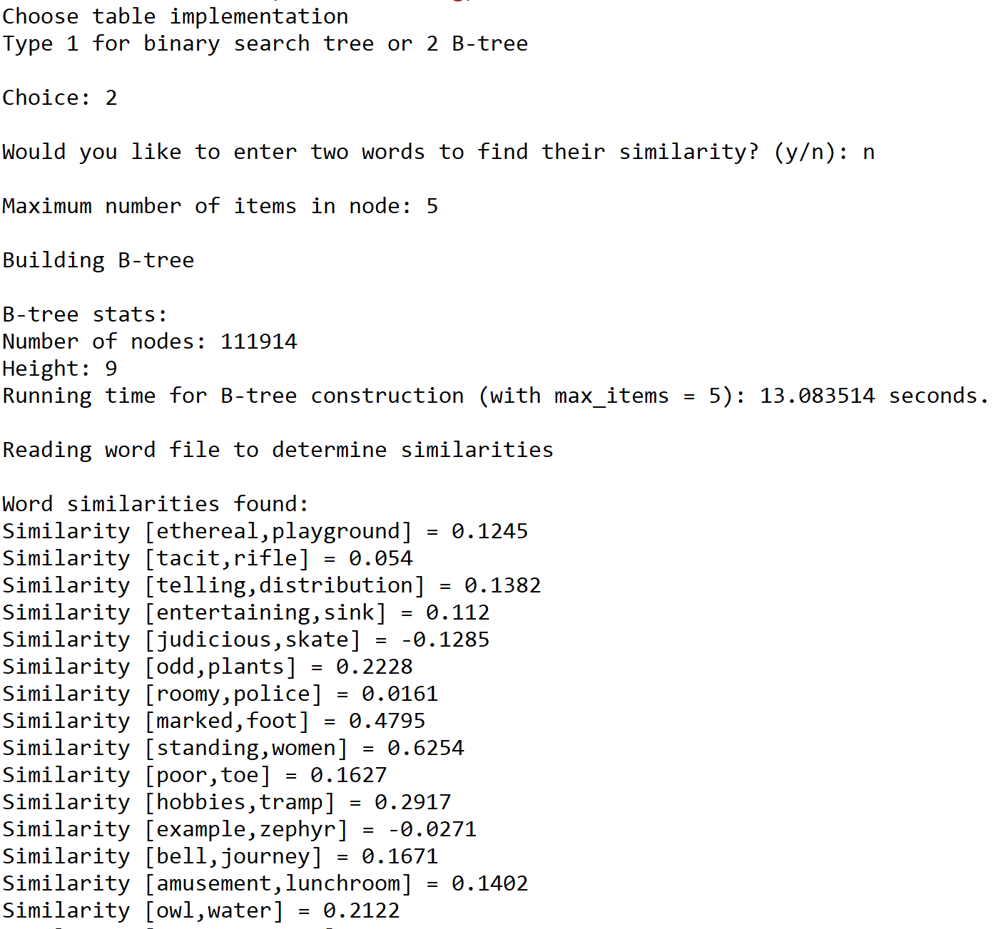

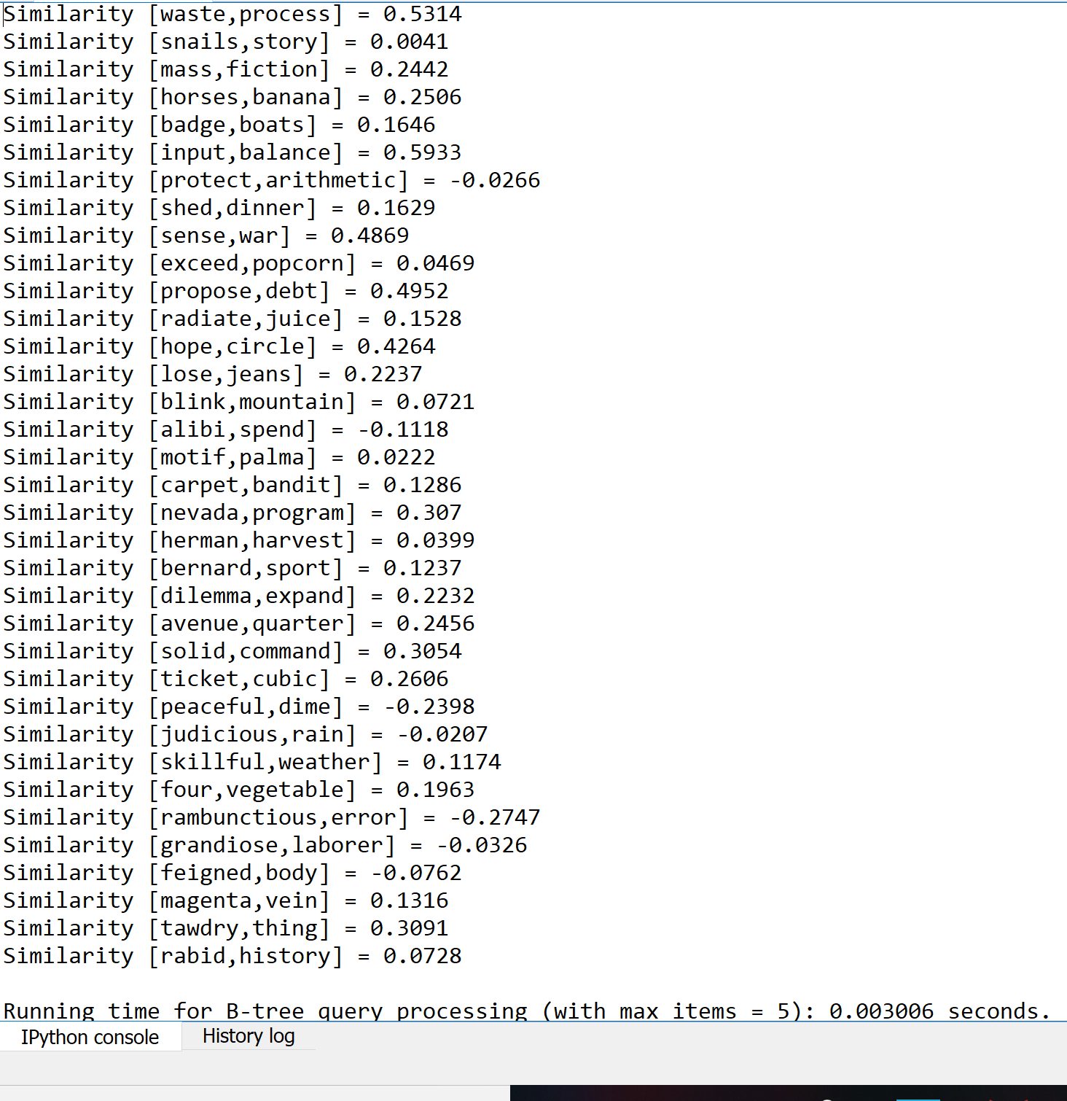

Case 1: Size of the text file = 50, maximum number of items in node = 10

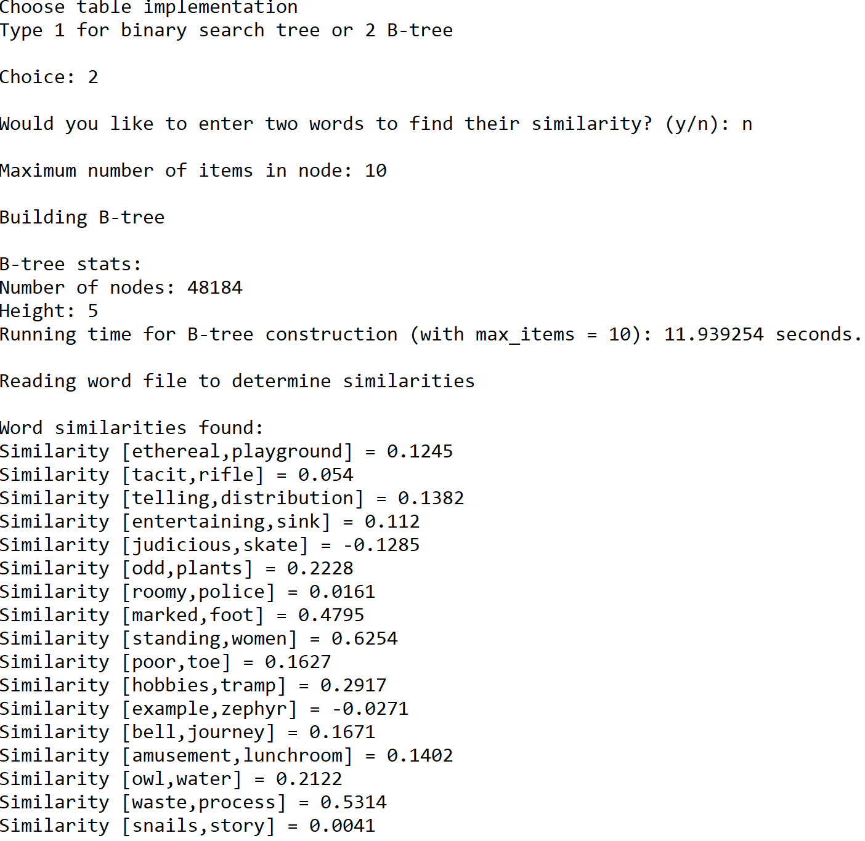

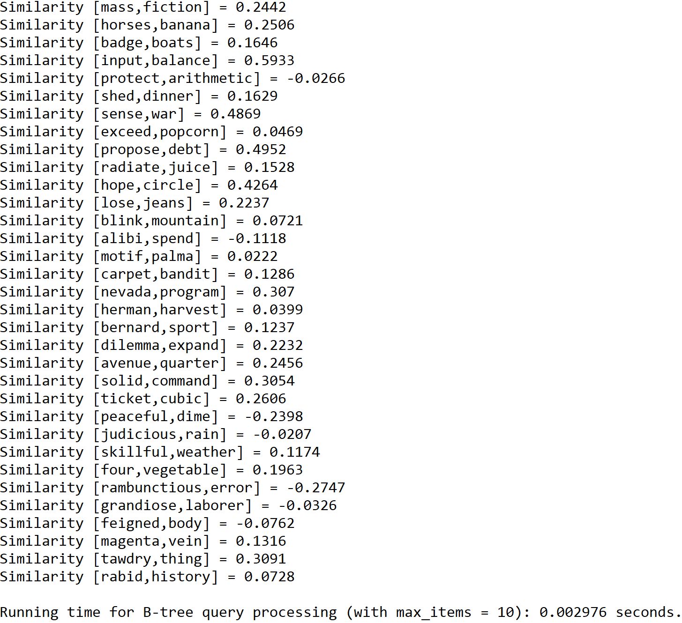

Case 1: Size of the text file = 50, maximum number of items in node = 15

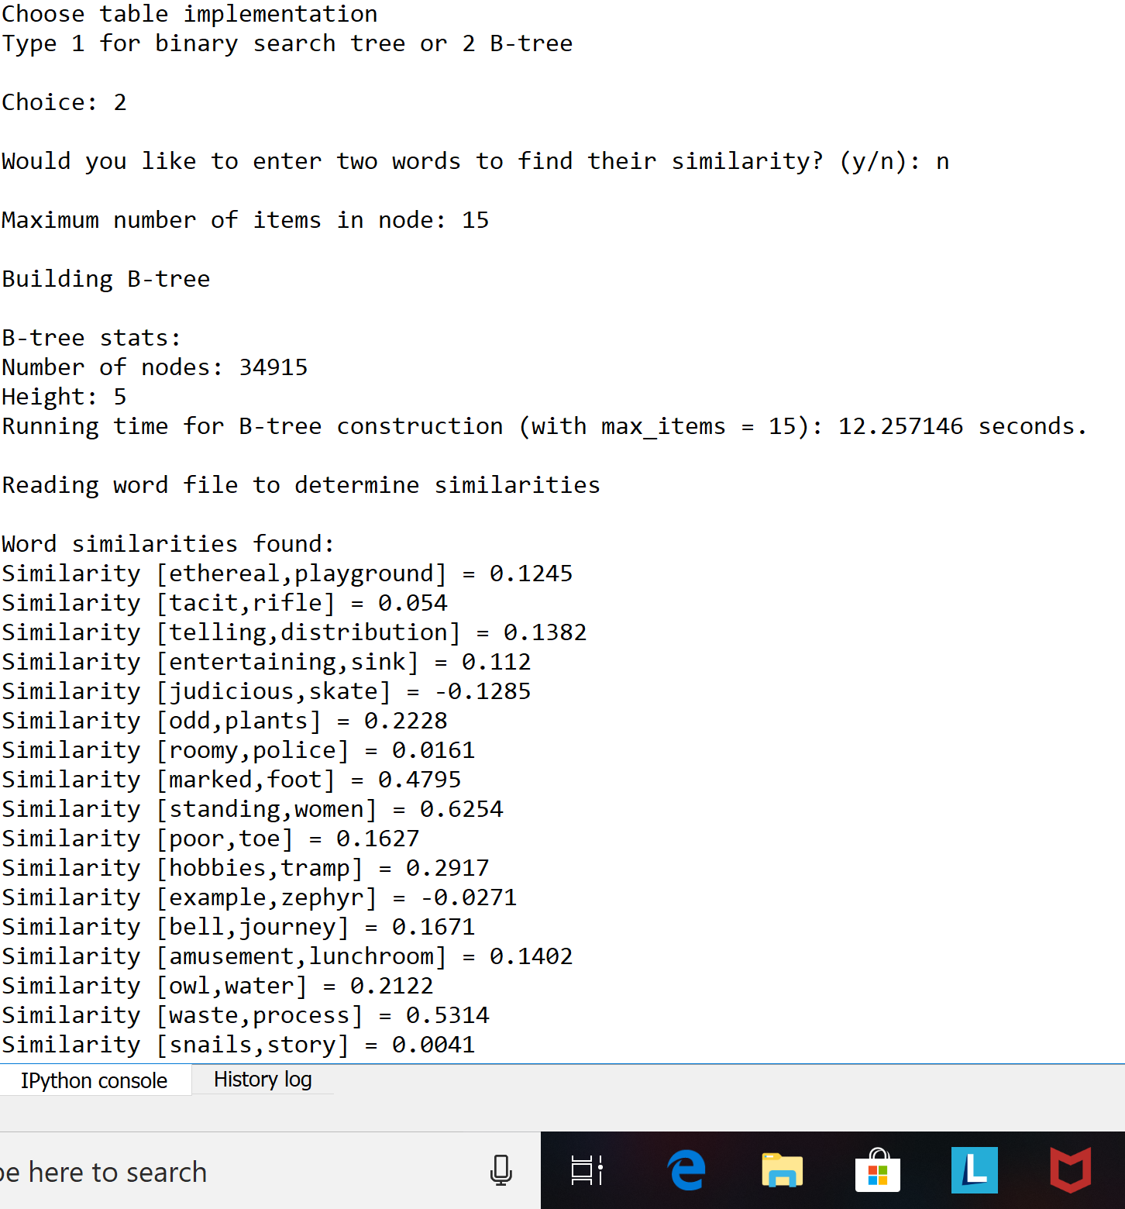

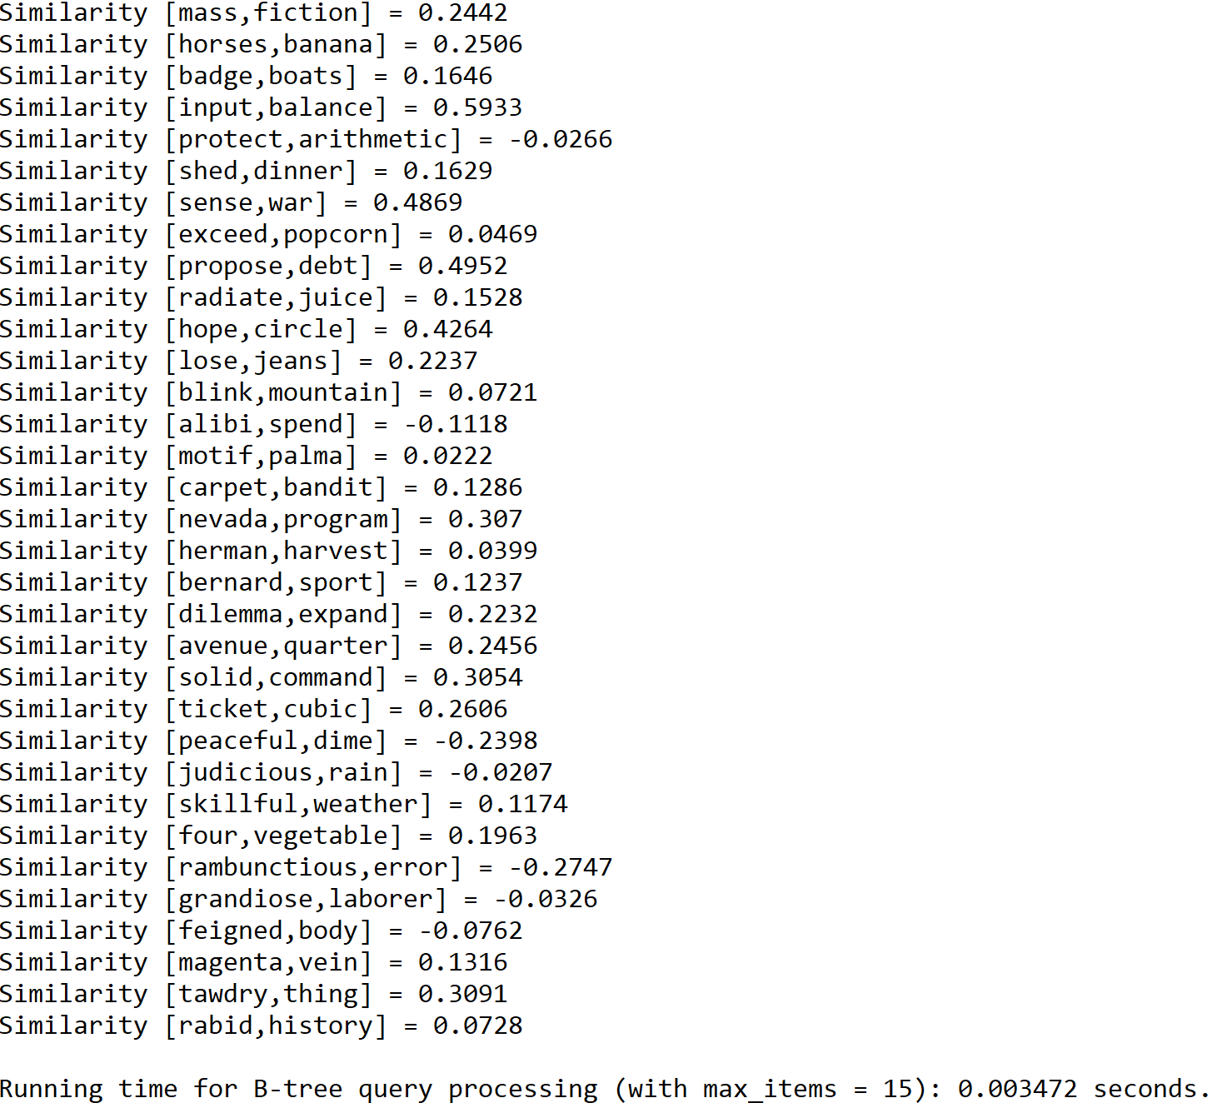

Case 1: Size of the text file = 50, maximum number of items in node = 20

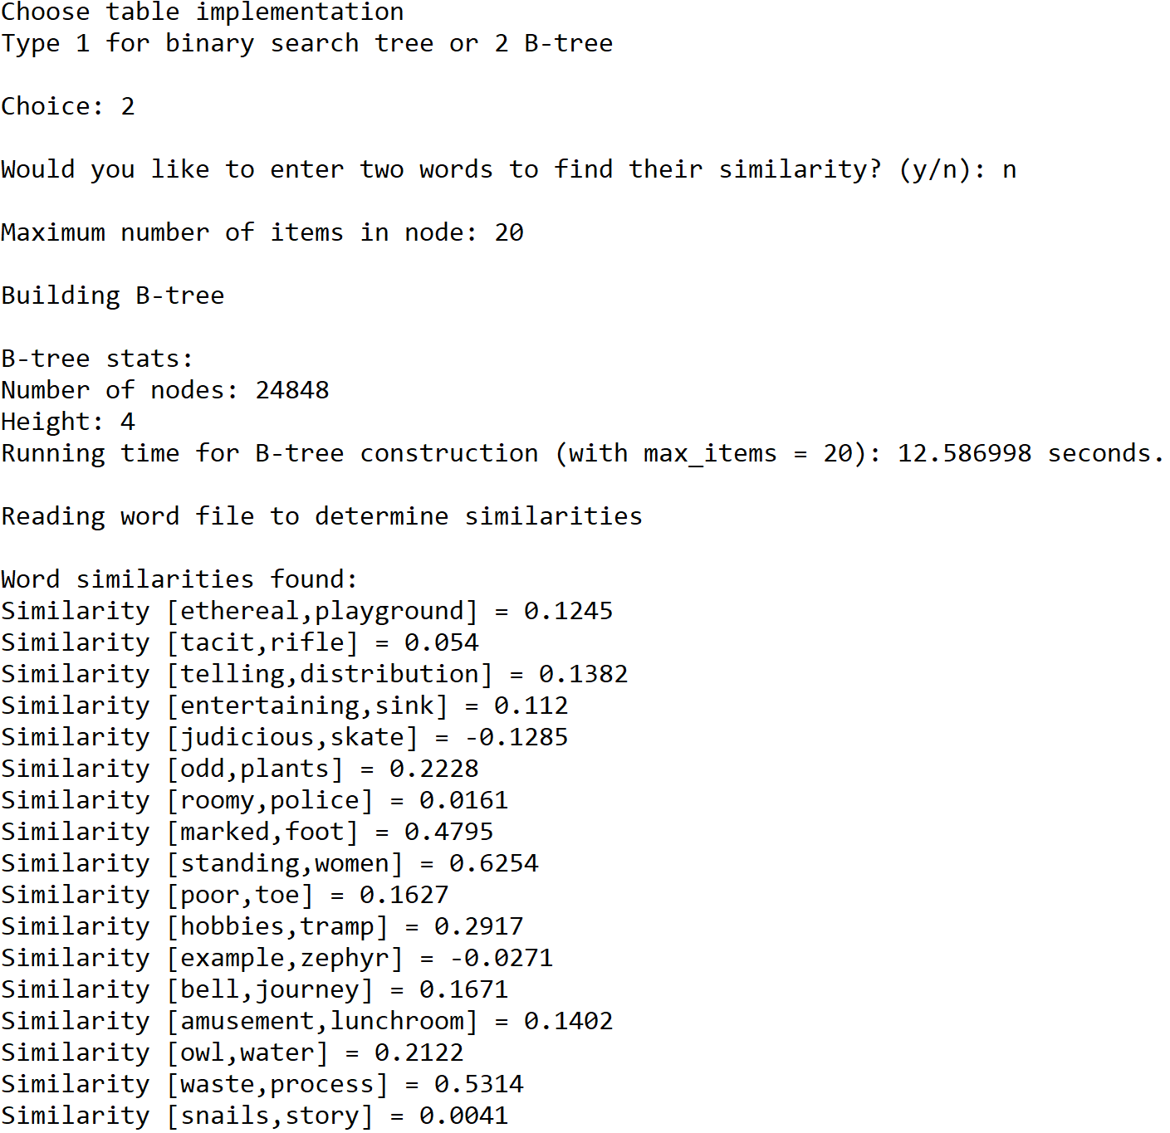

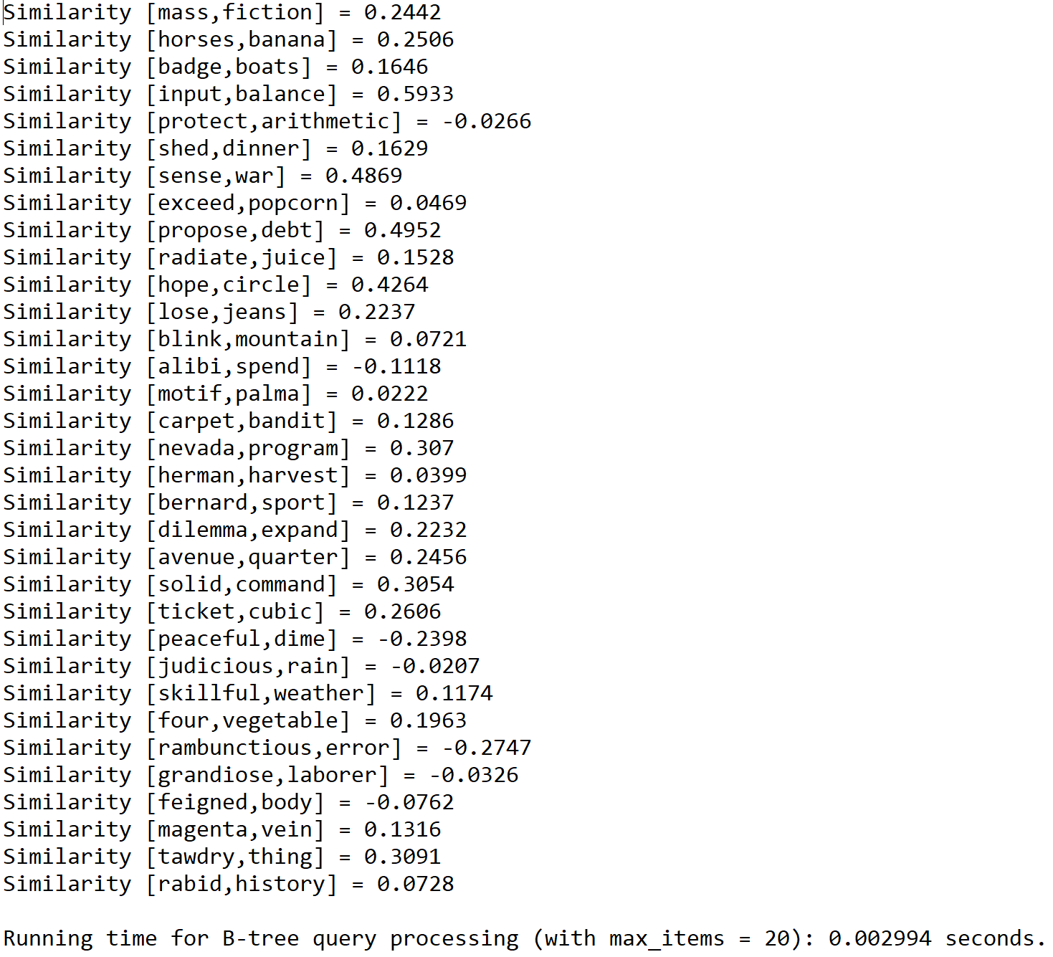

Case 2: Size of the text file = 100, maximum number of items in node = 5

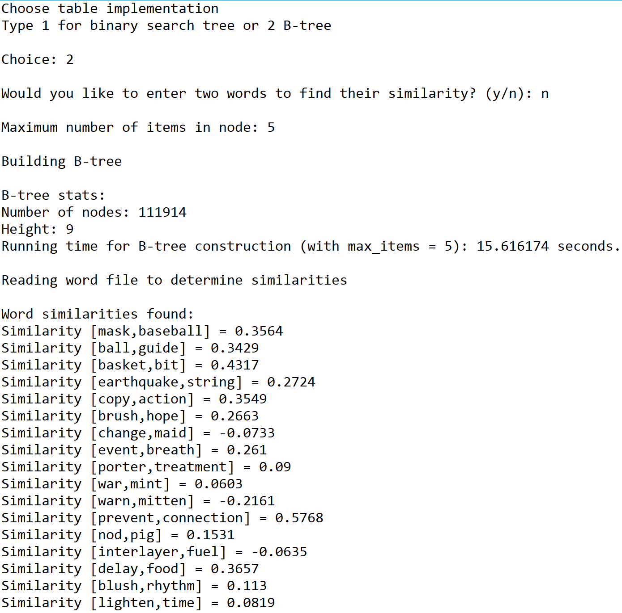

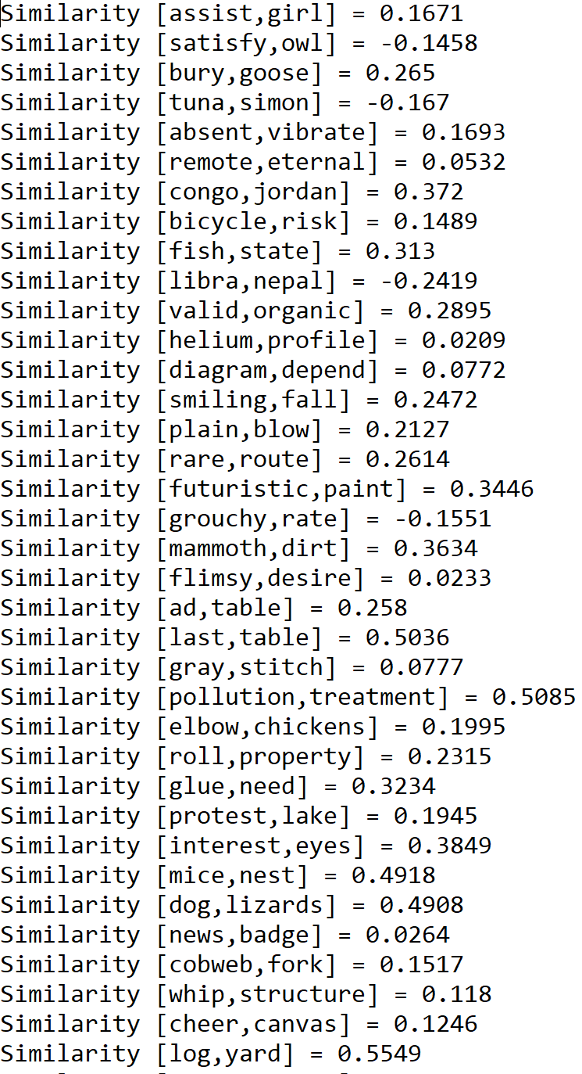

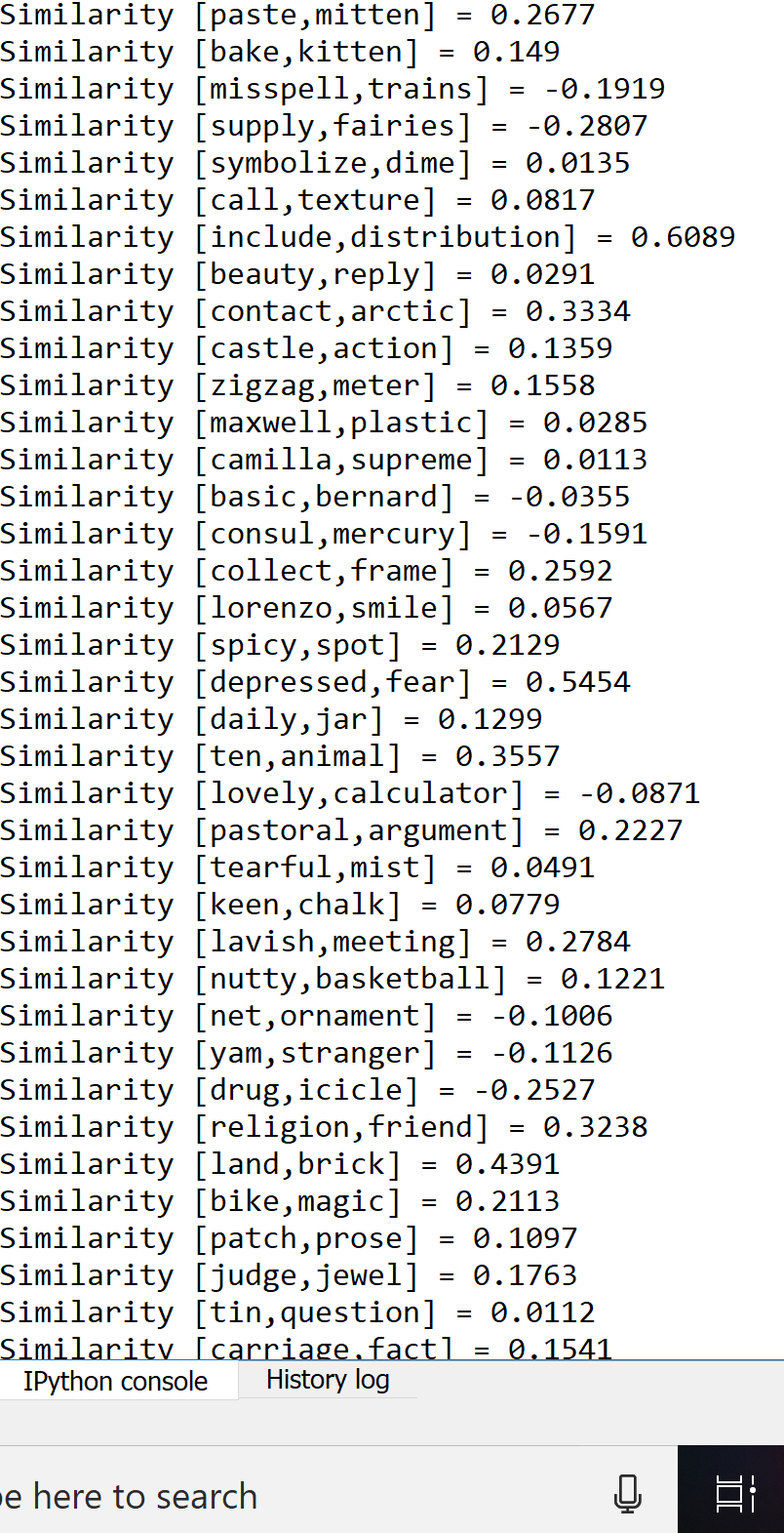

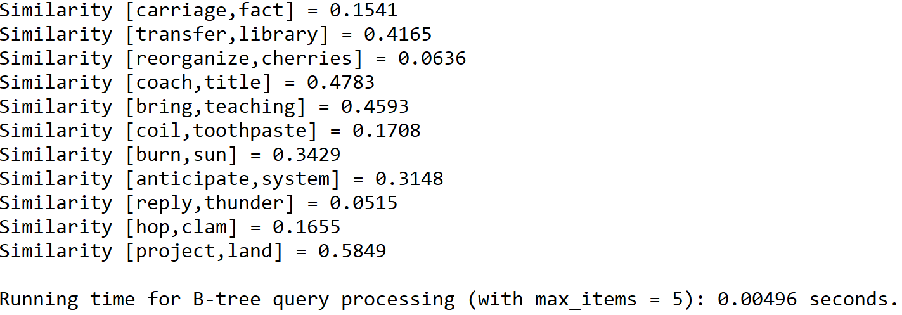

Case 2: Size of the text file = 100, maximum number of items in node = 10

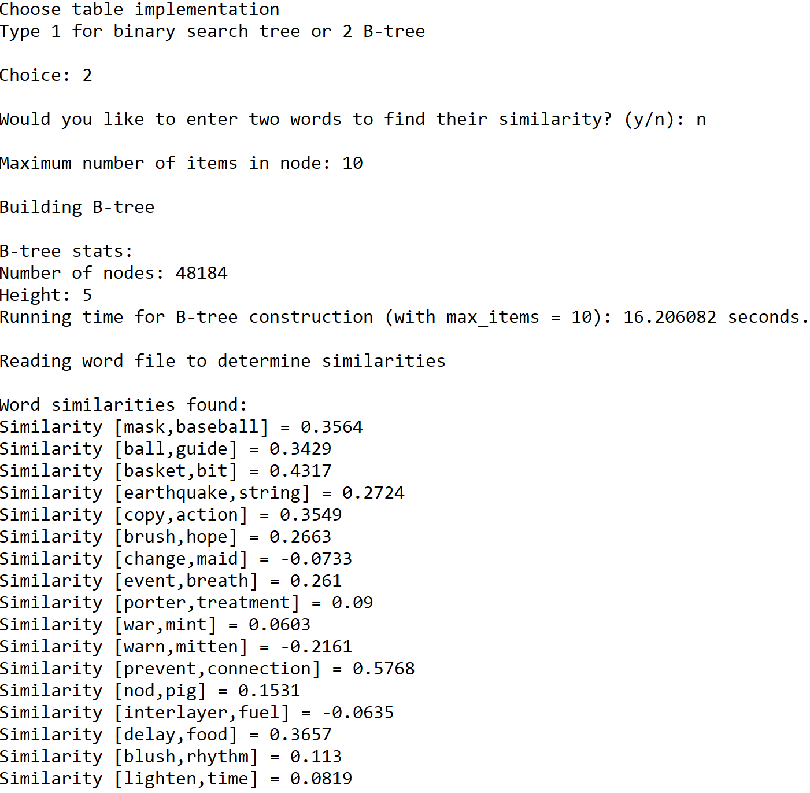





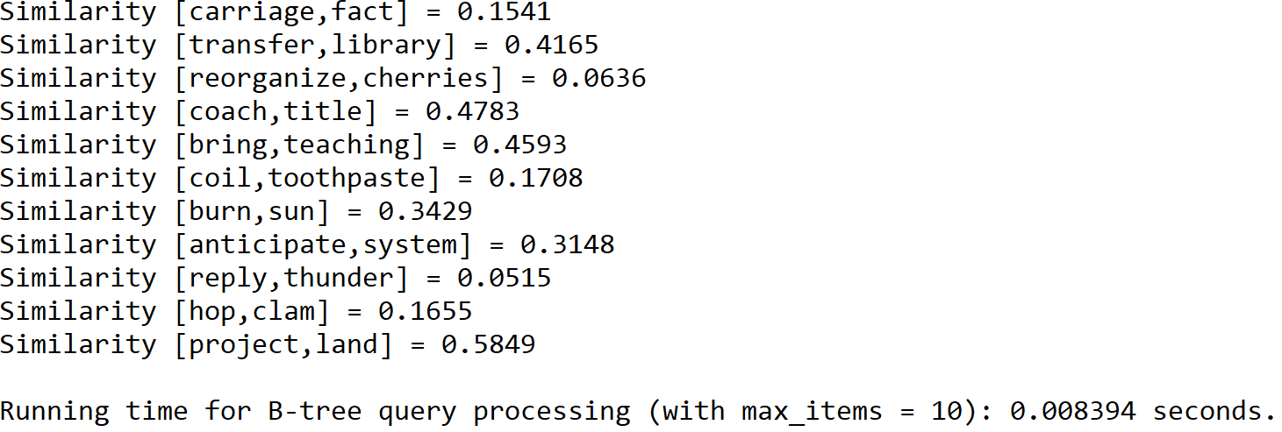

Case 2: Size of the text file = 100, maximum number of items in node = 15

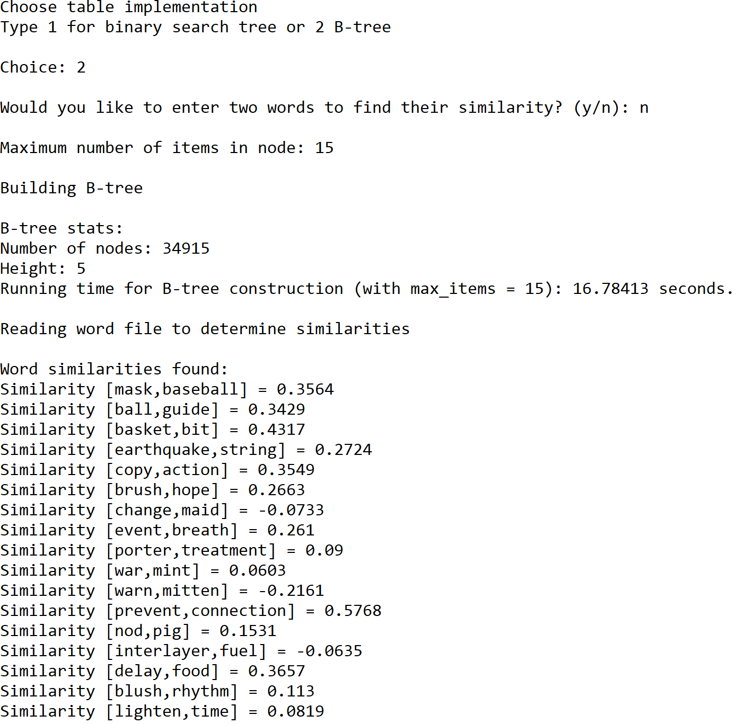





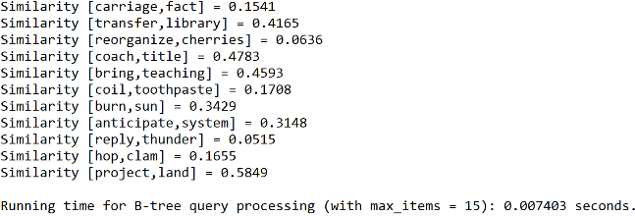

Case 2: Size of the text file = 100, maximum number of items in node = 20

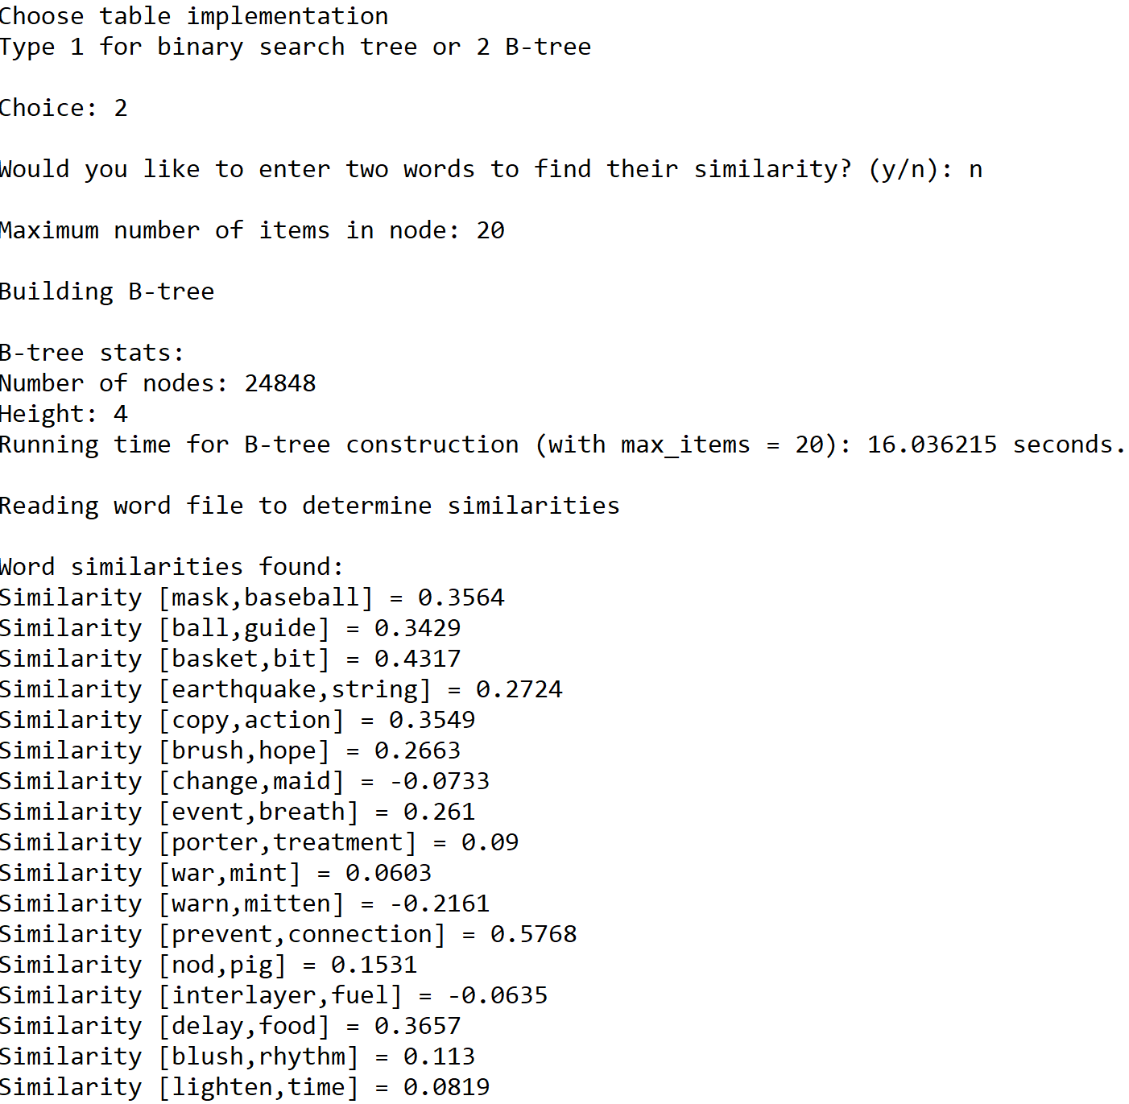





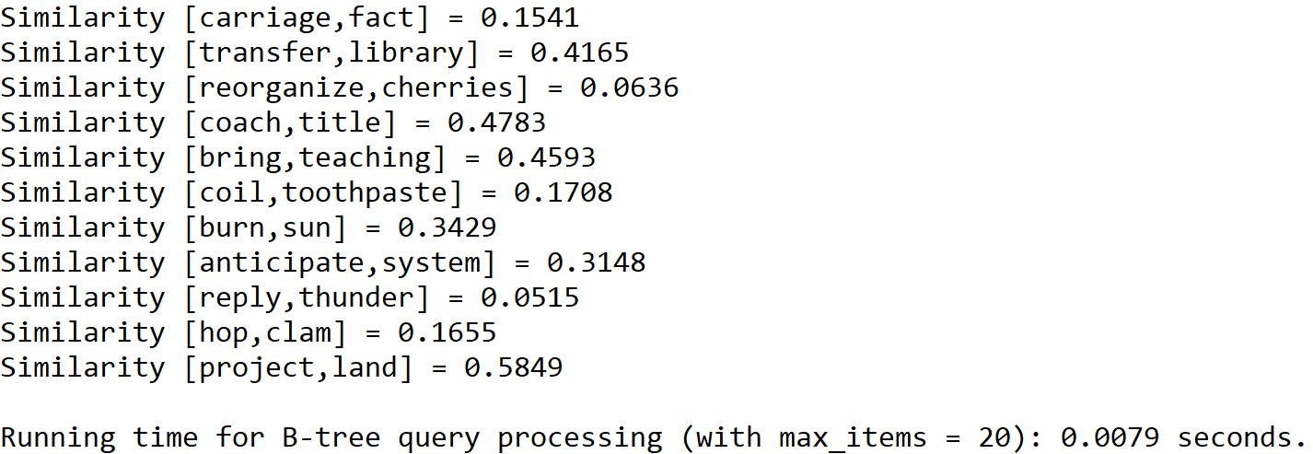

Case 3: Size of the text file = 150, maximum number of items in node = 5

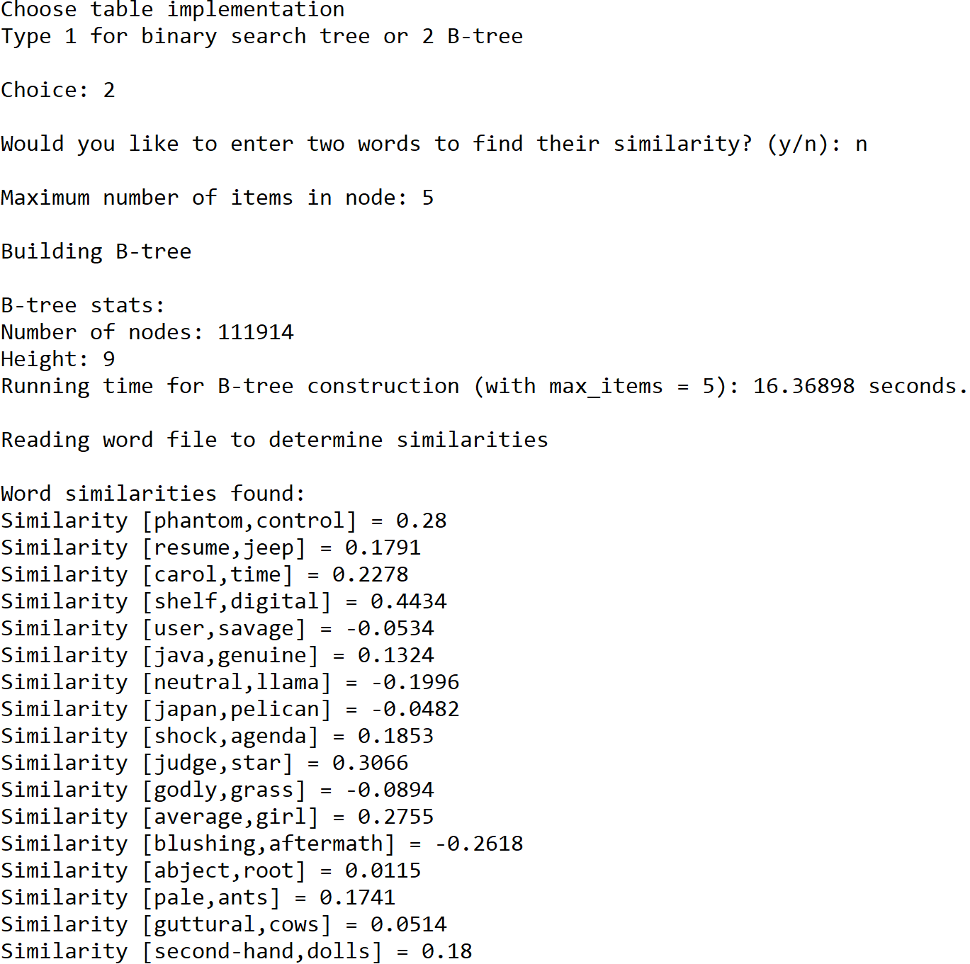

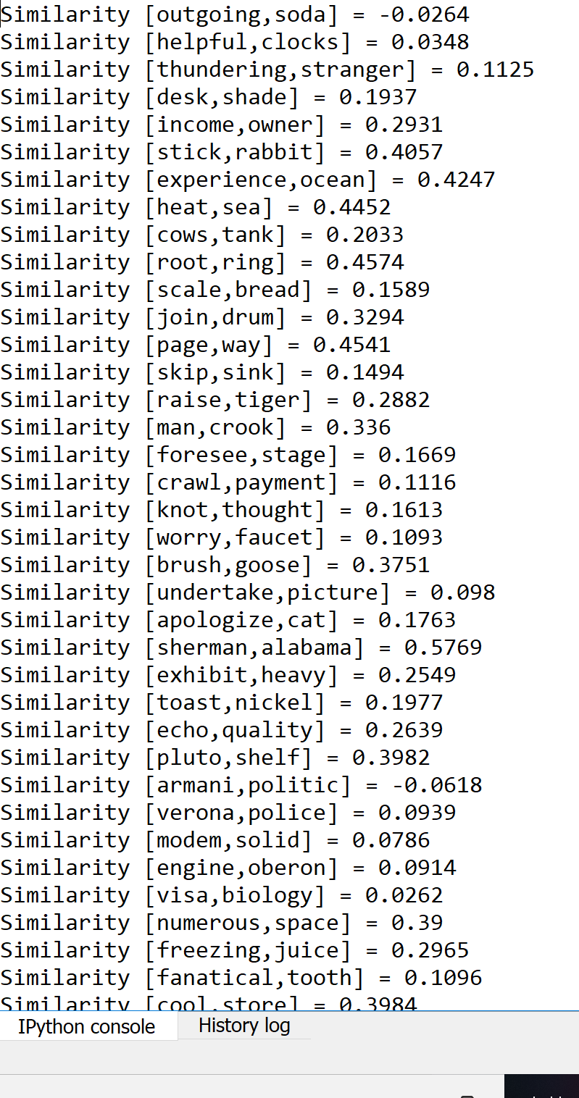

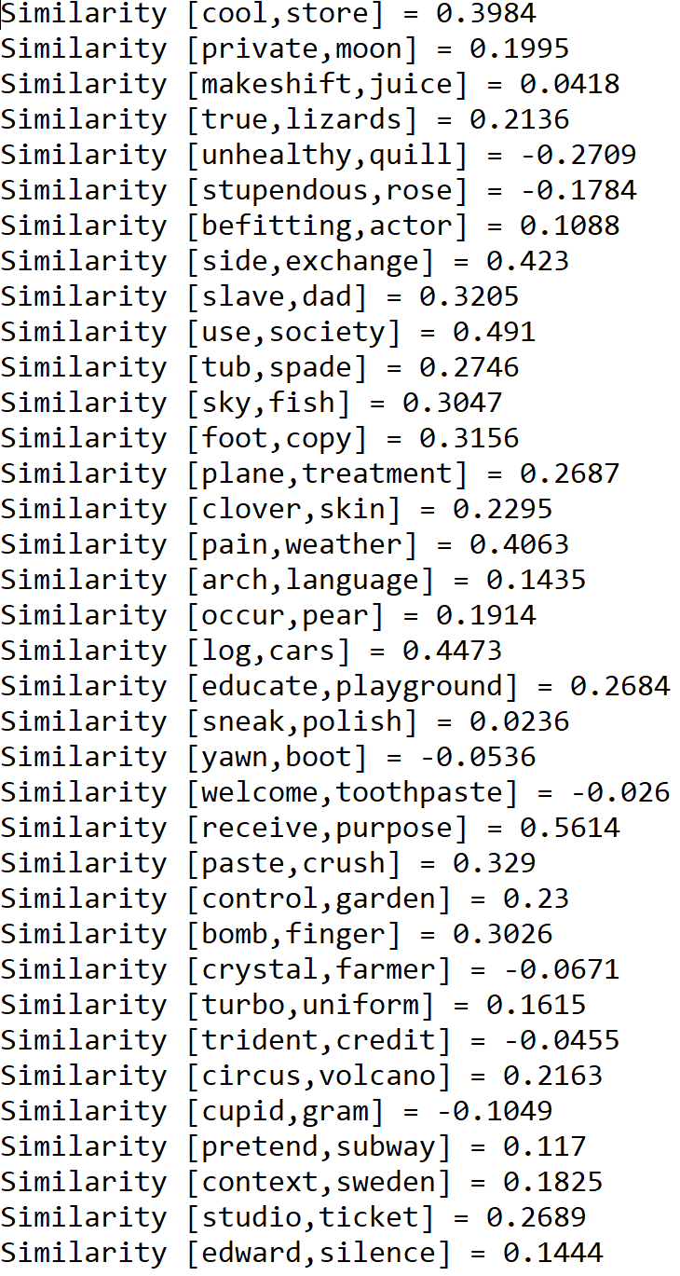

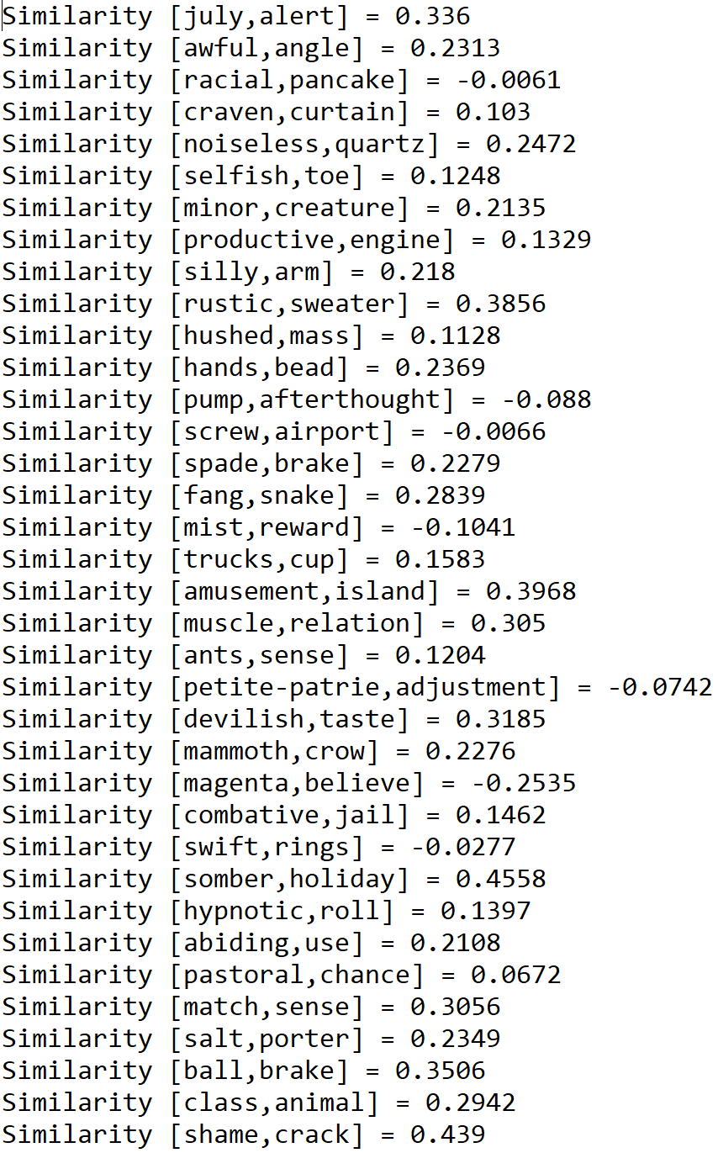

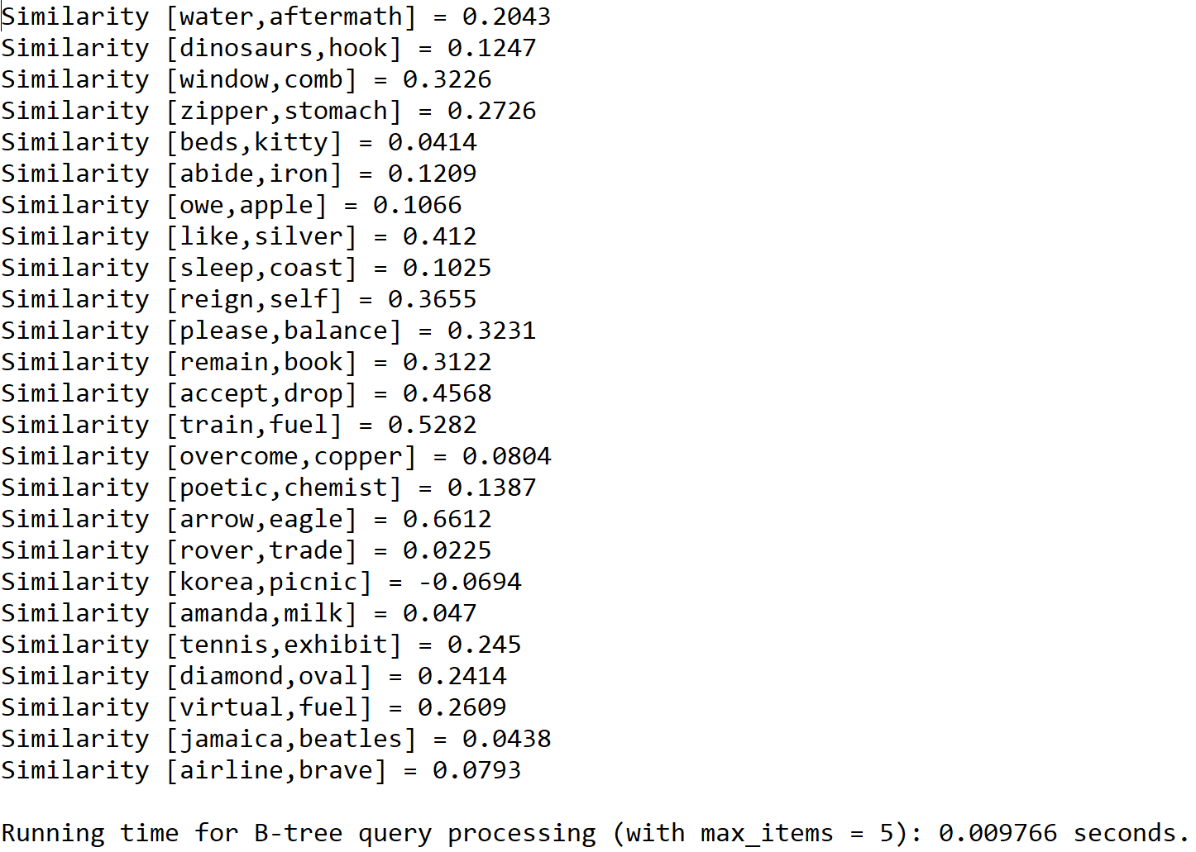

Case 3: Size of the text file = 150, maximum number of items in node = 10

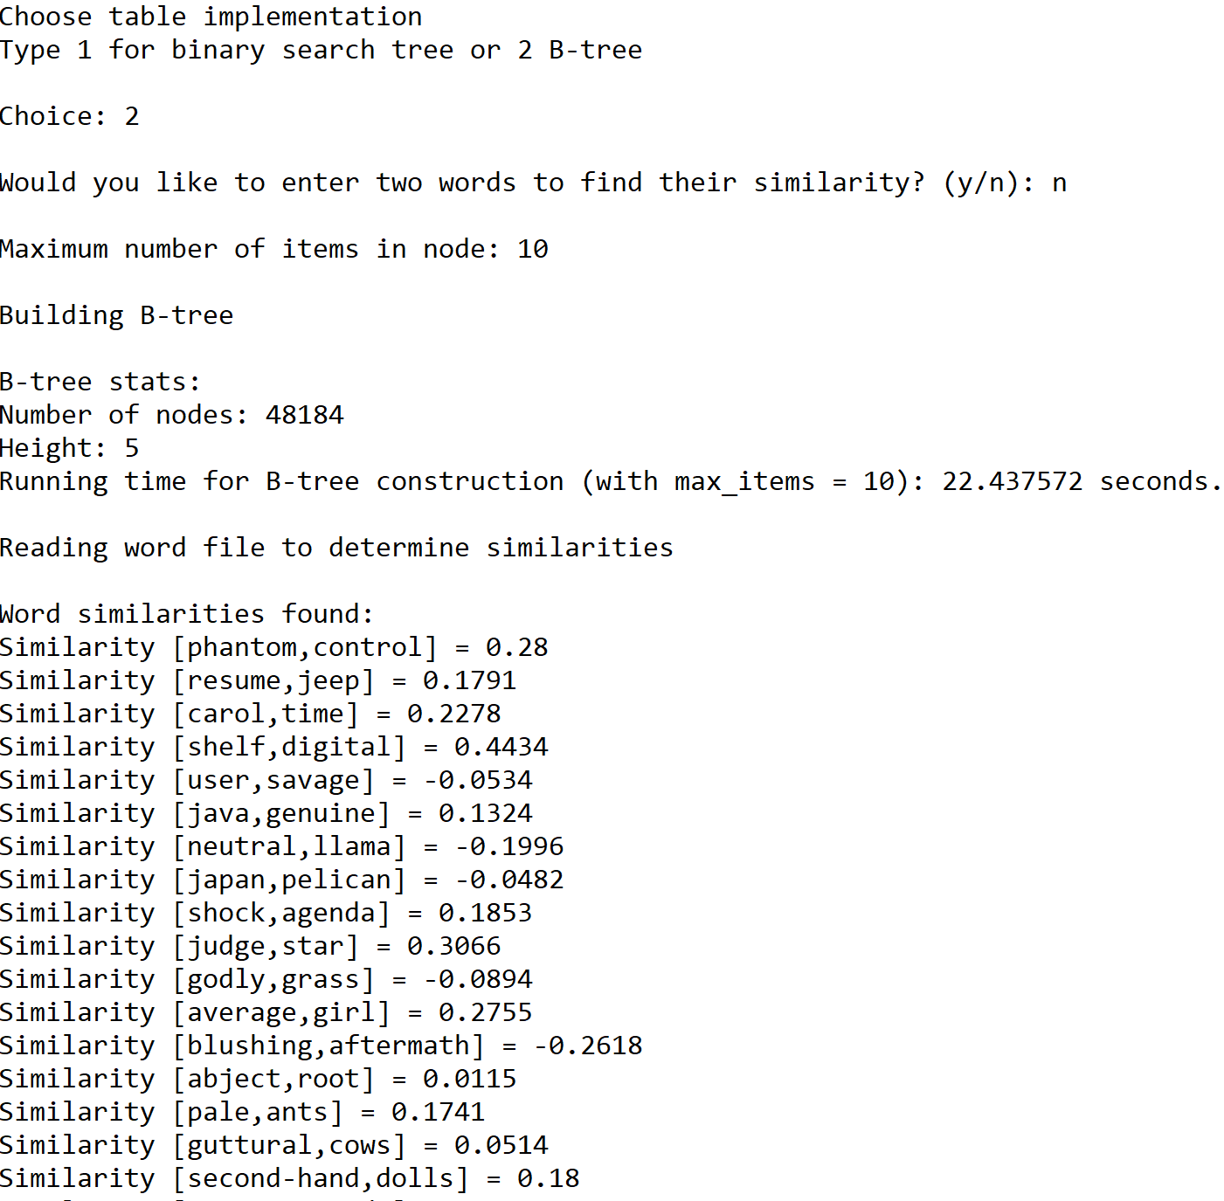







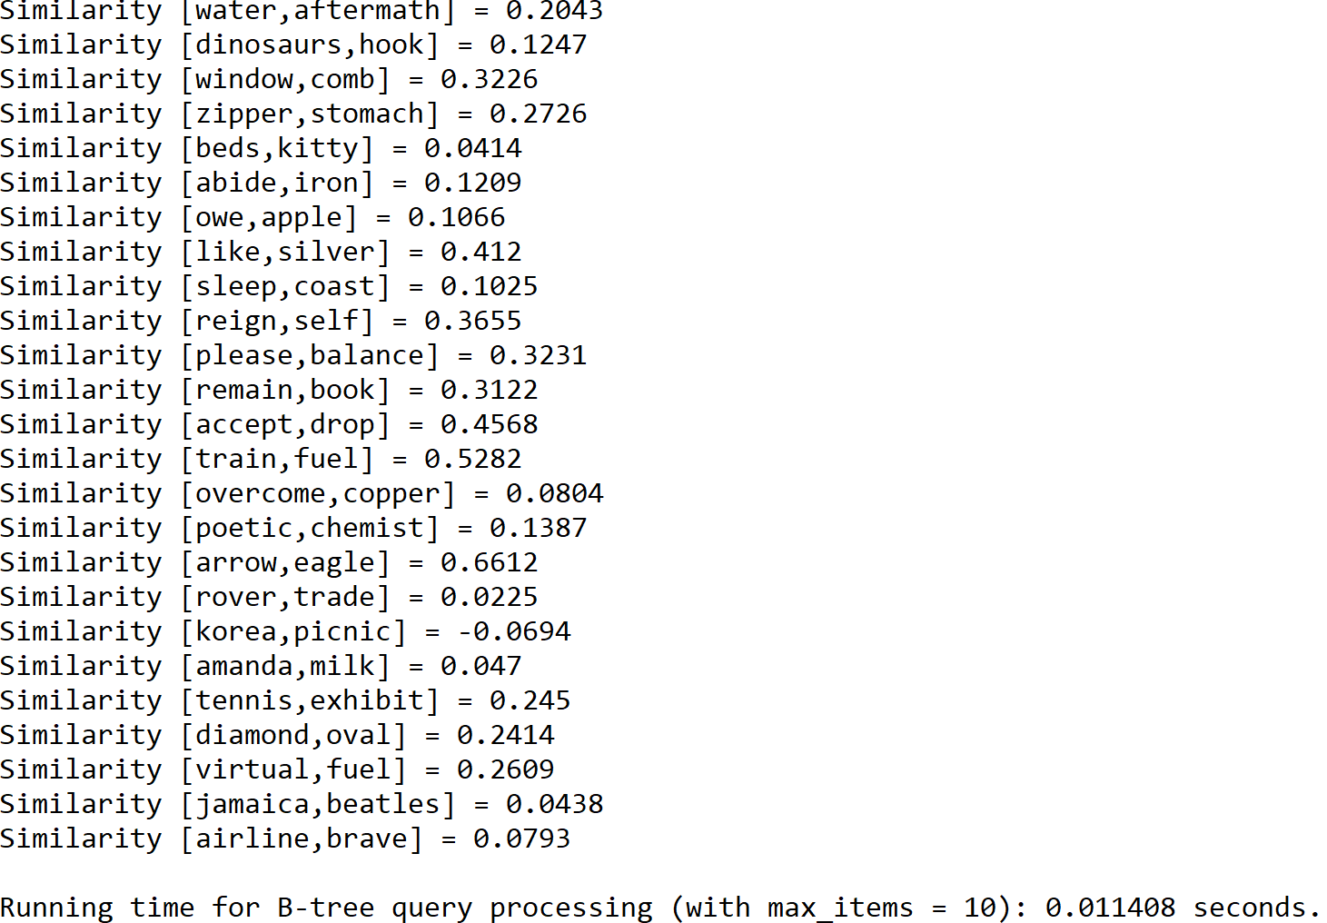

Case 3: Size of the text file = 150, maximum number of items in node = 15

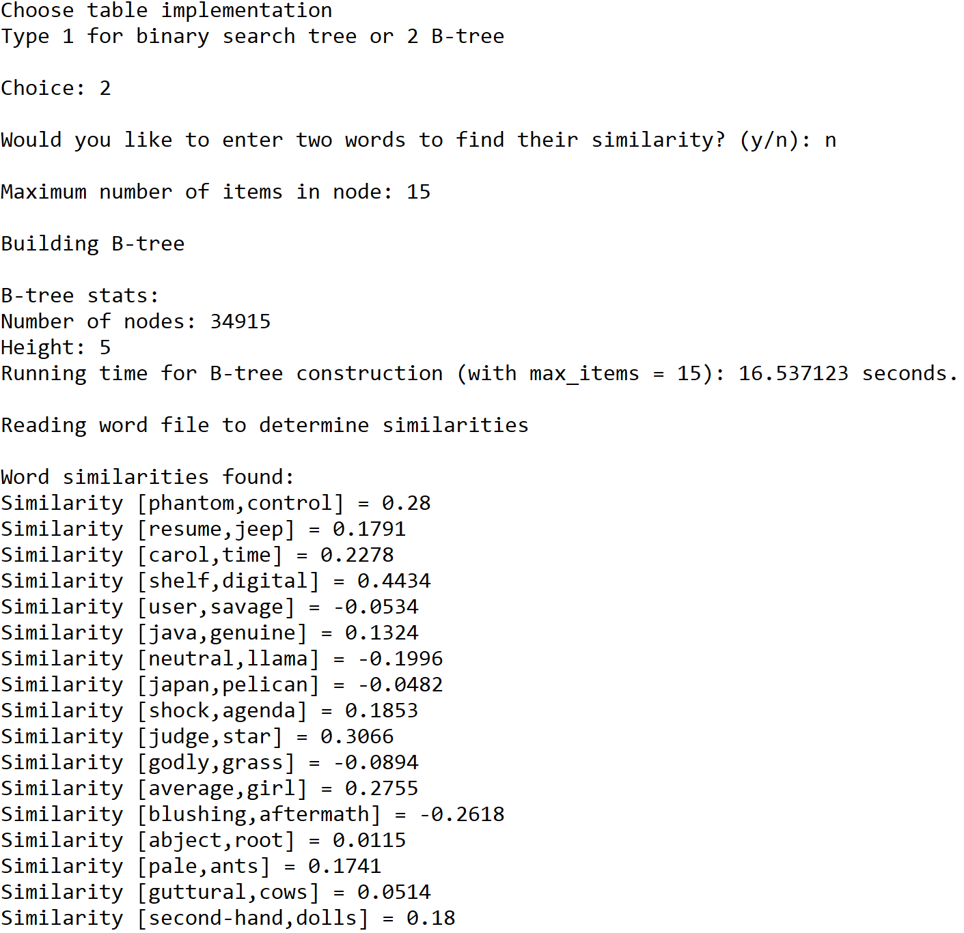







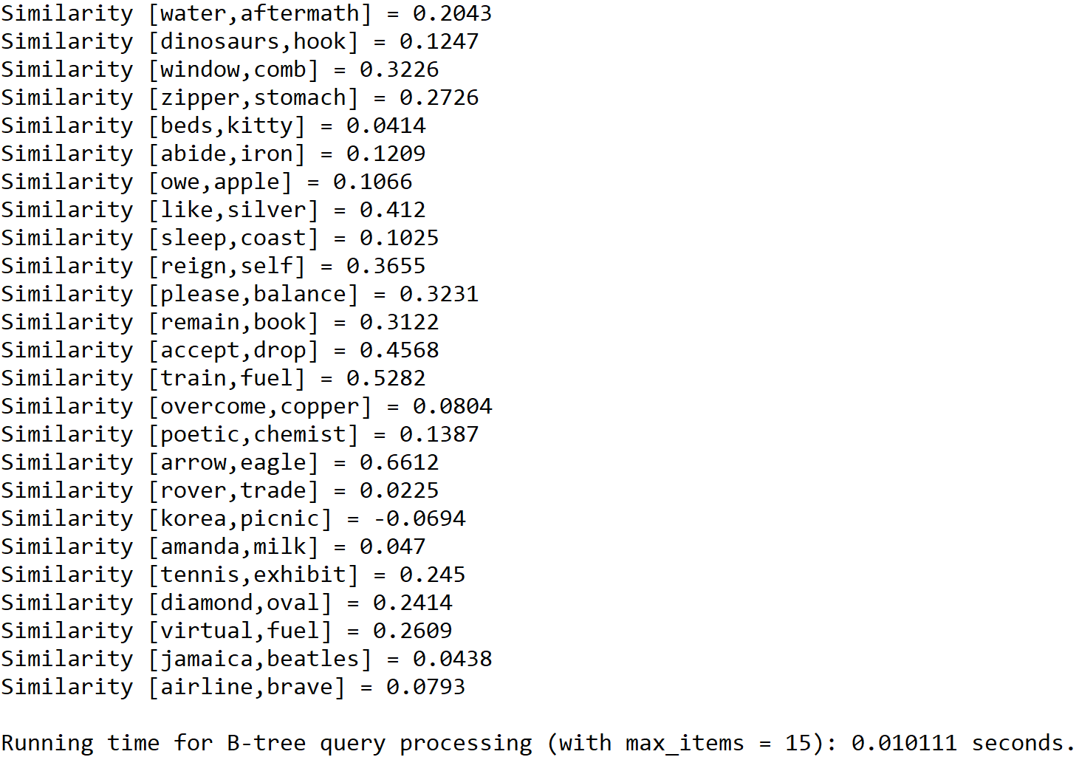

Case 3: Size of the text file = 150, maximum number of items in node = 20

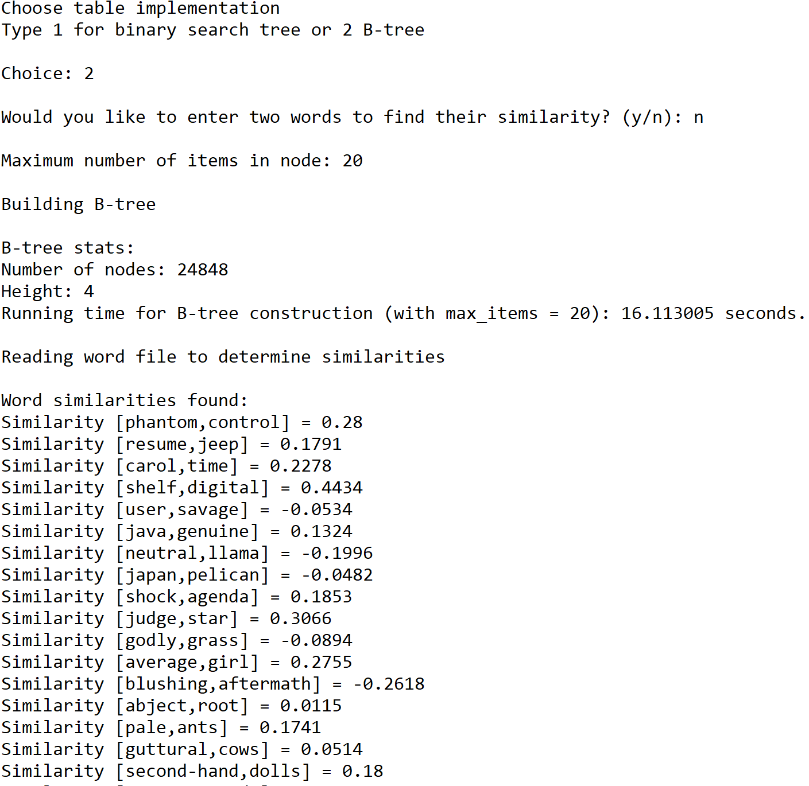







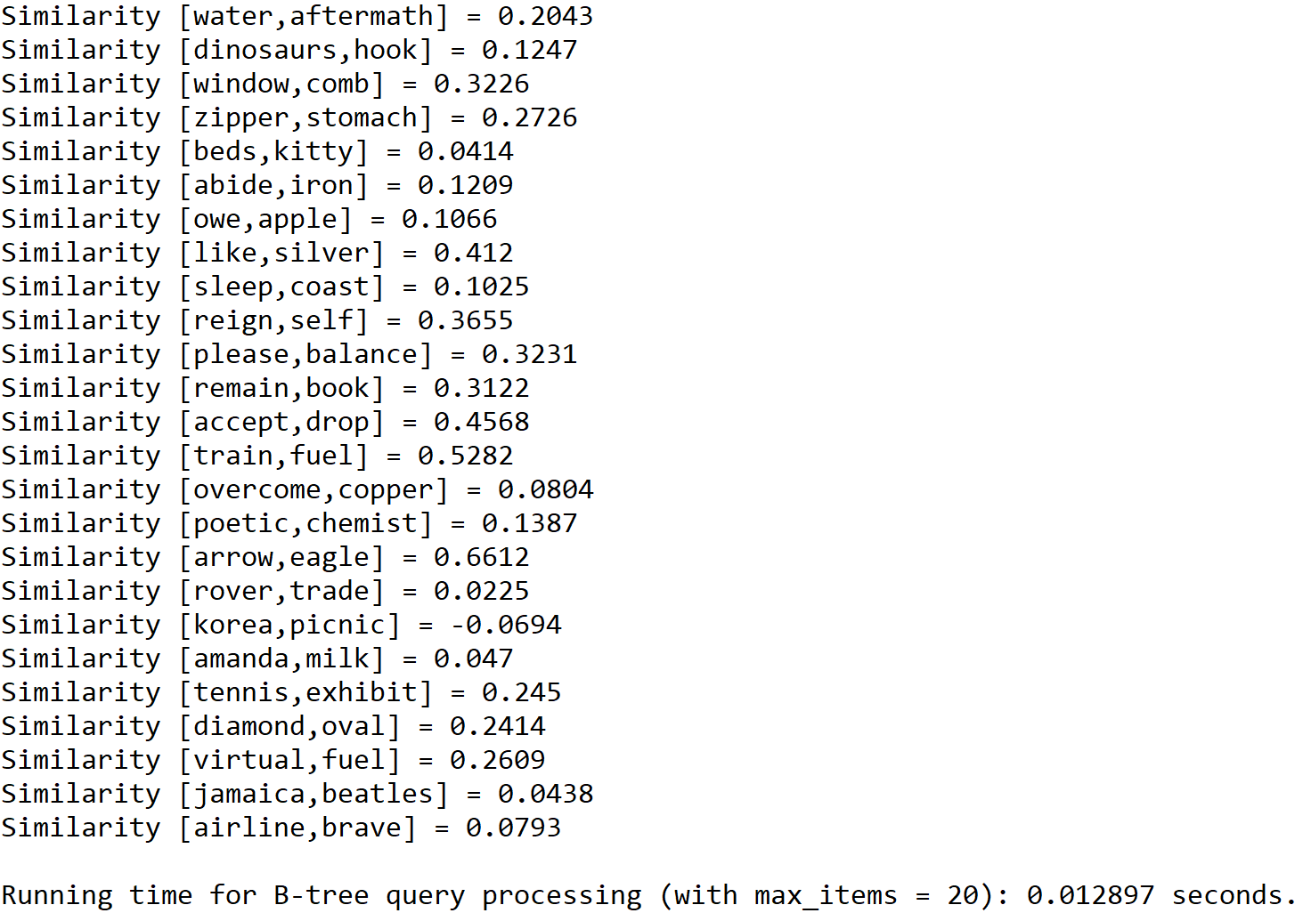

Case 4: Size of the text file = 200, maximum number of items in node = 5

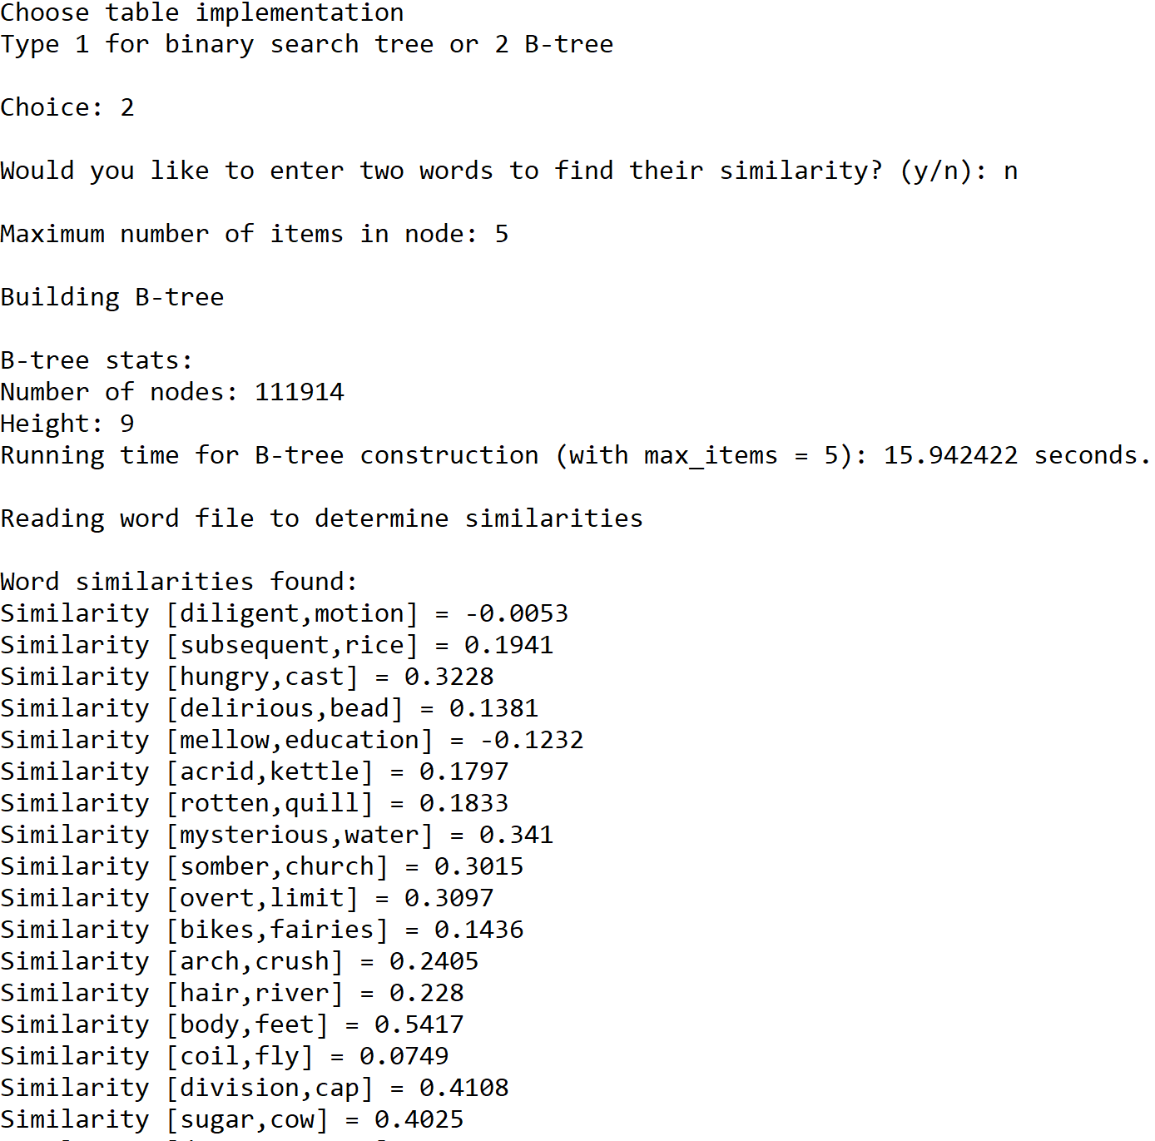











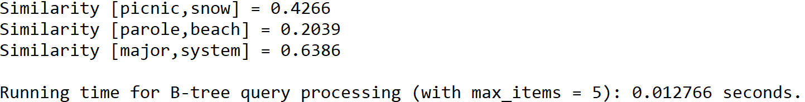

Case 4: Size of the text file = 200, maximum number of items in node = 10

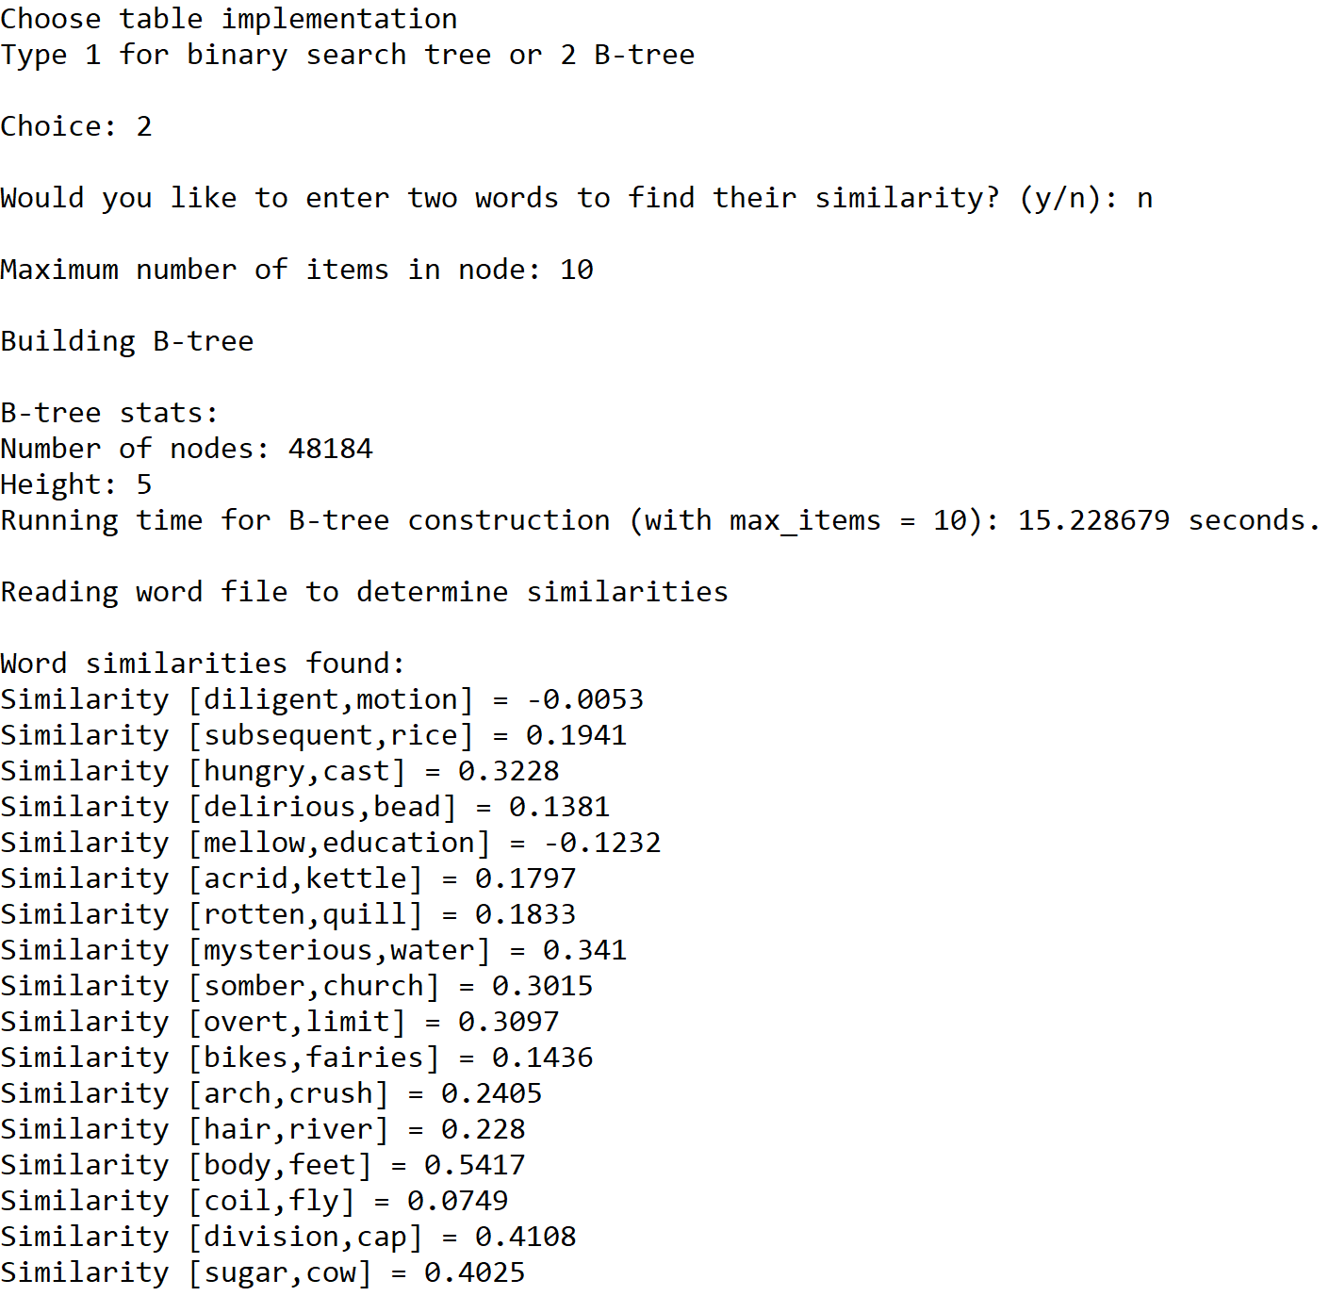











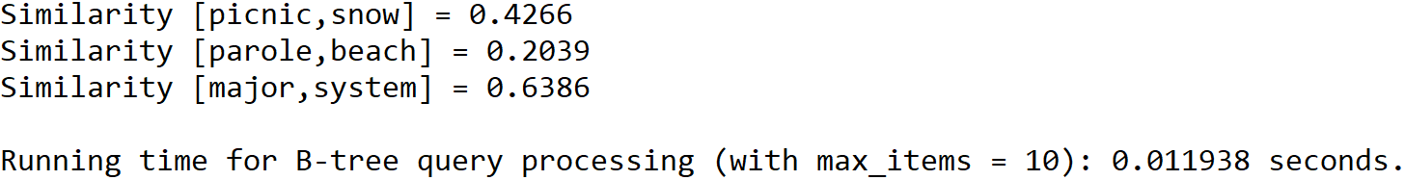

Case 4: Size of the text file = 200, maximum number of items in node = 15

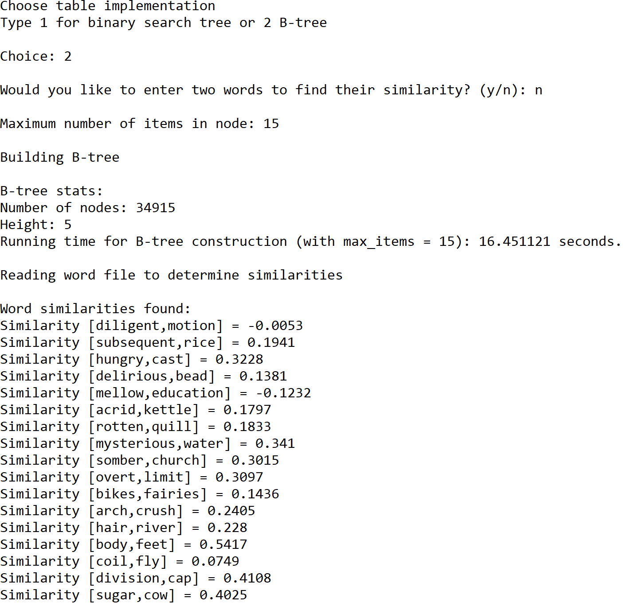











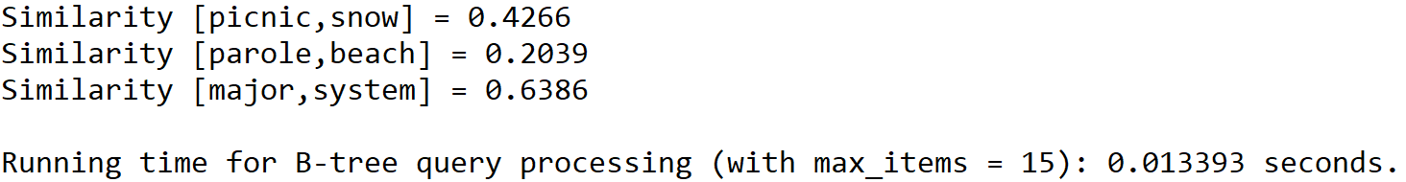

Case 4: Size of the text file = 200, maximum number of items in node = 20

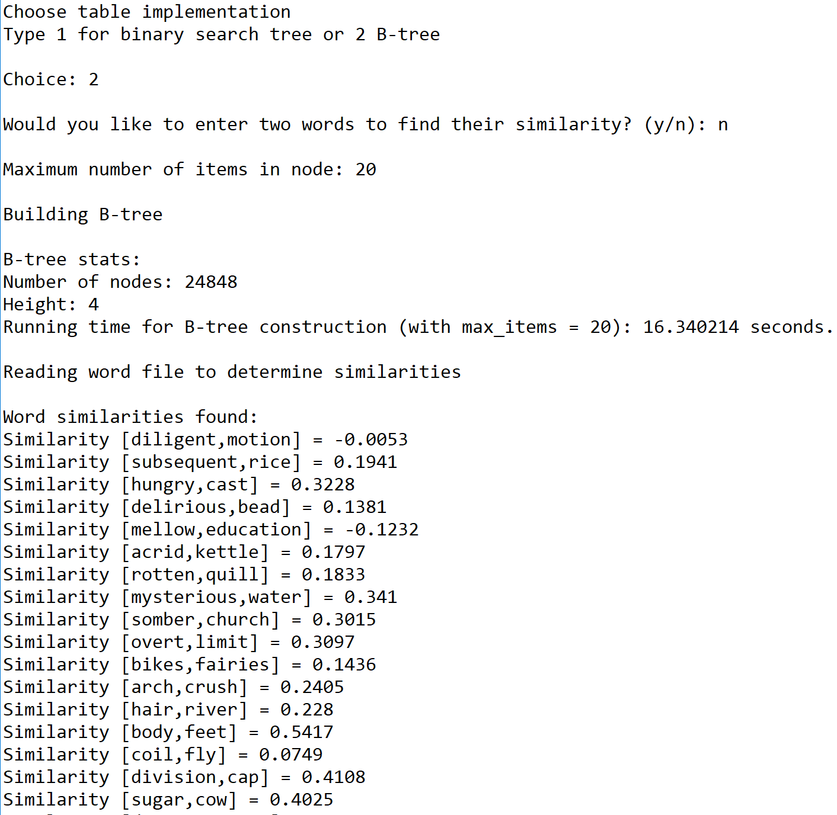











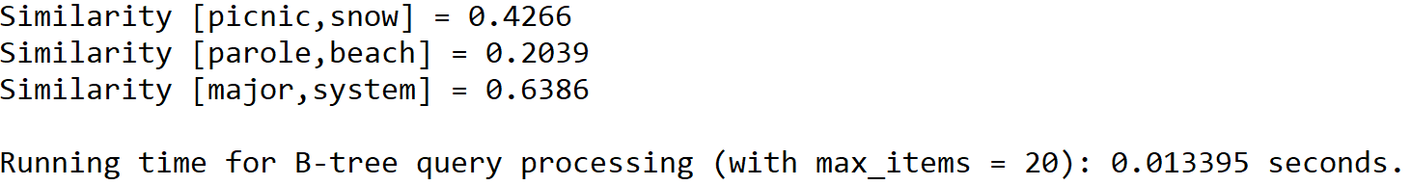

**Graphs of running times for query processing implemented with each operation**

N = Size of the text file(50, 100, 150, 200)

|  |  |  |
| --- | --- | --- |
| Size of the text file | Operation 1 (BST) | Operation 2 (B-Tree) |
| 50 | 0.001984 | 0.003006 |
| 100 | 0.003950 | 0.004960 |
| 150 | 0.006481 | 0.009766 |
| 200 | 0.008965 | 0.012766 |

|  |  |  |  |  |
| --- | --- | --- | --- | --- |
| Size of the text file | B-Tree with max_data = 5 | B-Tree with max_data = 10 | B-Tree with max_data = 15 | B-Tree with max_data = 20 |
| 50 | 0.003006 | 0.002976 | 0.003472 | 0.002994 |
| 100 | 0.004960 | 0.008394 | 0.007403 | 0.007900 |
| 150 | 0.009766 | 0.011408 | 0.010111 | 0.012897 |
| 200 | 0.012766 | 0.011938 | 0.013393 | 0.013395 |

As the results show, the BST implementation is more efficient than the B-Tree implementation when it comes to comparing various pairs of words by retrieving their corresponding embeddings. When the text file is small (i.e. the size of the text file is between 50 and 100), the running times of both implementations appear to be relatively close to each other even though the BST implementation appears to take less time than the B-Tree implementation to process a text file of this size. However, the difference between the running times of the two implementations is more significant when the text file is large (i.e. the size of the text file is greater than 100). At this point, it becomes clear that the BST implementation is more efficient than the B-Tree implementation. The efficiency of the BST implementation can be attributed to the fact that this implementation operates by traversing a specific path along the BST in order to find the node that contains the searched word and its corresponding embedding. On the other hand, the B-Tree implementation also operates by traversing a specific path along the B-Tree in order to find that node. However, this implementation traverses through the node itself in order to find the WordEmbedding object that contains the searched word and its corresponding embedding. Because of this additional traversal through the searched node, the B-Tree implementation takes longer than the BST implementation to retrieve word embeddings that are used to compare pairs of words.

In terms of the choice of parameters of the B-Tree (i.e. the maximum number of items in a B-Tree node), it affects the space and time of the B-Tree implementation. In terms of space, increasing the maximum number of items in a B-Tree node decreases the total number of nodes the tree has and the height of the tree, which makes it easier to find the node where a searched word is in the B-Tree. However, increasing the maximum number of items in a B-Tree node also increases the size of the data in each node, which causes this implementation to take more time traversing through the node to find the WordEmbedding object that matches with the searched word. In terms of time, increasing the maximum number of items in a B-Tree node causes the B-Tree node to take more time retrieving word embeddings as seen by the significant difference in the running times between a B-Tree implementation with nodes containing a maximum of five WordEmbedding objects and a B-Tree implementation with nodes containing a maximum of 20 WordEmbedding objects. Overall, the efficiency of the B-Tree implementation surprisingly decreases as the maximum number of items in a B-Tree node increases.

**Conclusion**

This lab helped me understand BSTs and B-Trees better by allowing me to analyze the properties of each data structure in order to write similar functions for each data structure. For example, the *height(T)* function calculates the height of a tree. For the BST implementation, I needed to write that function in such a way that it traverses through the entire tree in order to find the longest path from the root node to the appropriate leaf node. For the B-Tree implementation, I took advantage of the fact that all paths in a B-Tree from the root node to a leaf node have the same length; therefore, I wrote that same function in such a way that it traverses through a single path from the root node to a leaf node to calculate the height of the B-Tree. Additionally, this lab helped me understand B-Trees better by allowing me to examine the ways in which a change in the B-tree’s parameters (i.e. the change in the maximum number of items in a B-Tree node) can affect the structure of the tree by changing its properties, such as its height and the number of nodes it has.

In addition to BSTs and B-Trees, this lab helped me understand the way in which word embeddings represent words. Word embeddings are multidimensional coordinates represented as vectors of floating-point numbers that map words in a multidimensional graph. This type of graph is used for data models that utilize Machine Learning algorithms to determine the similarity among various words. These types of algorithms then utilize formulas, such as the cosine distance, to determine the proximity of words in the multidimensional graph, which relates to their similarity. Word embeddings are useful for representing words because many computer algorithms cannot process plain text in its raw form. Therefore, they need an efficient way to represent words to be able to compare the relevancy of one word with the rest of the words written in the same sentence. That way, searching relevant topics for any given word(s) can be done as efficiently as possible.

**Appendix**

BST.py

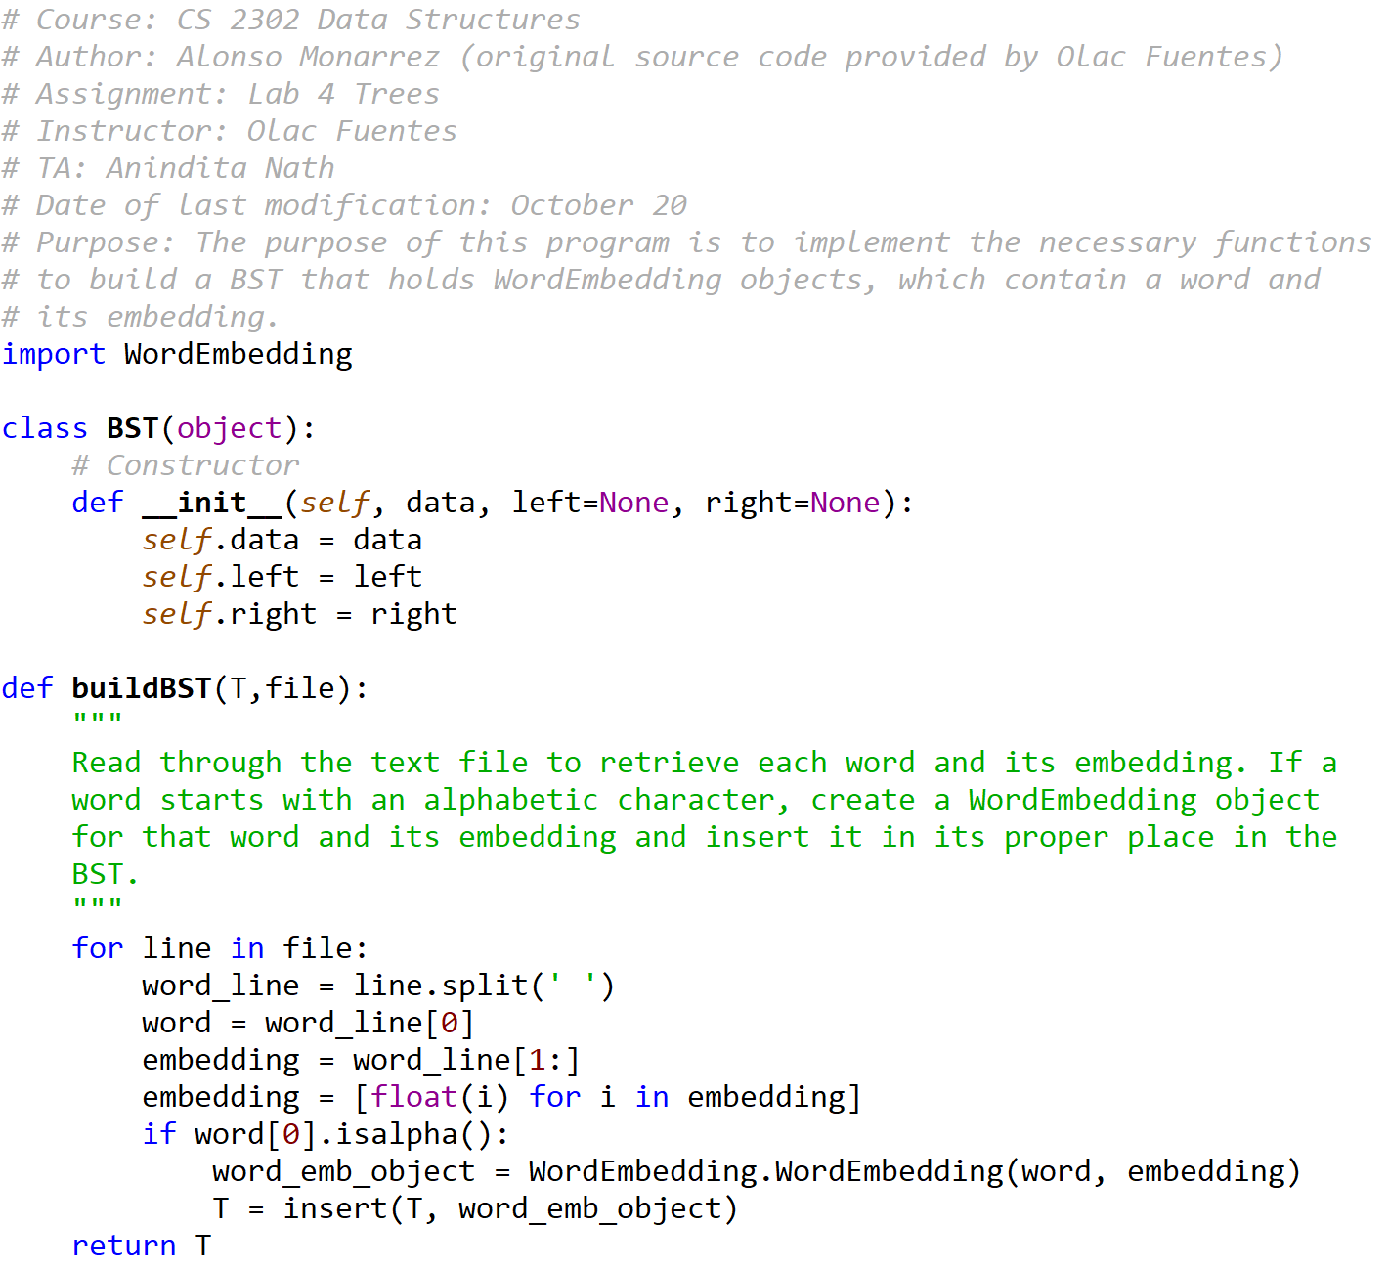

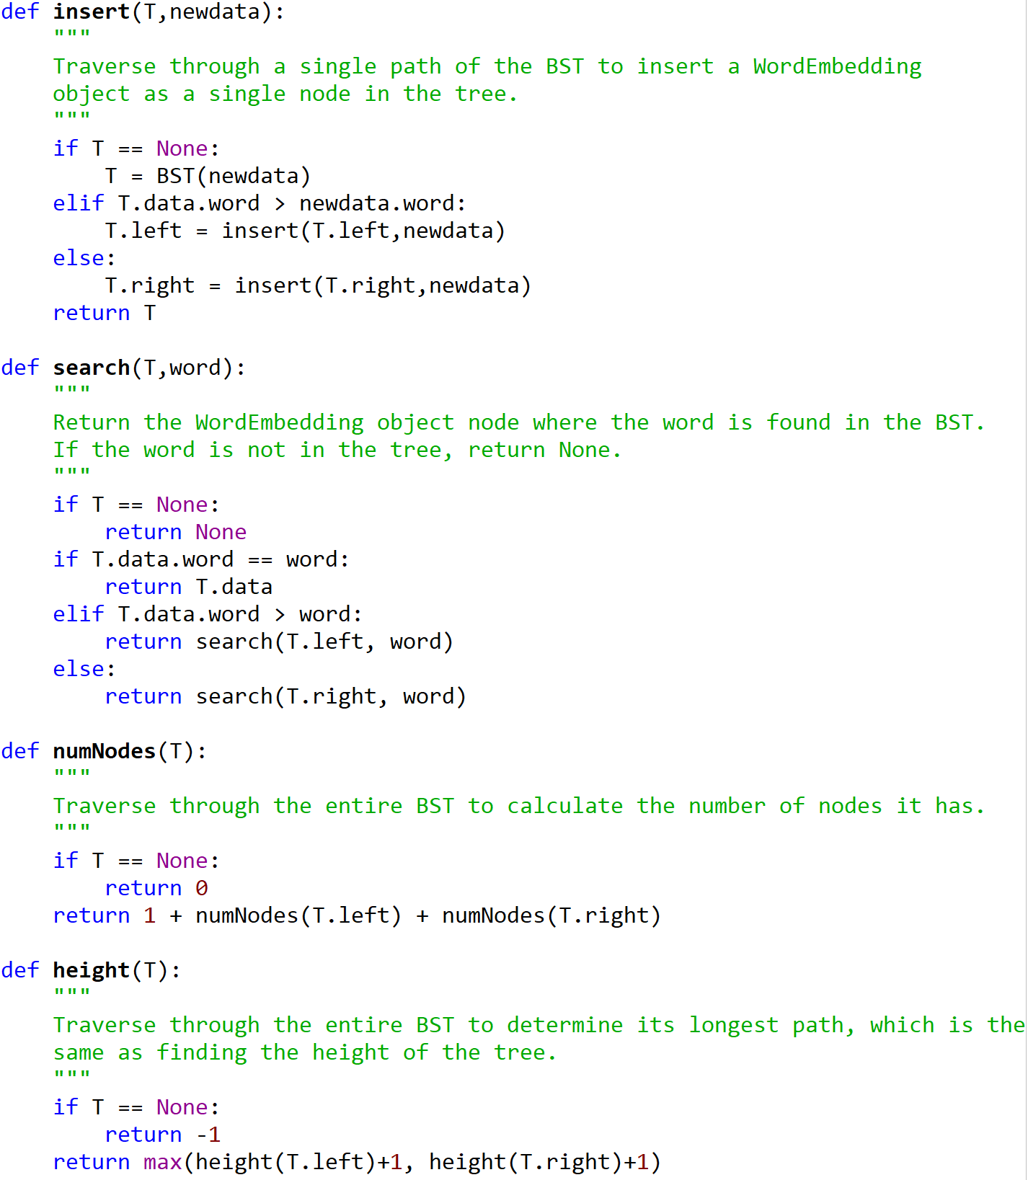





BTree.py

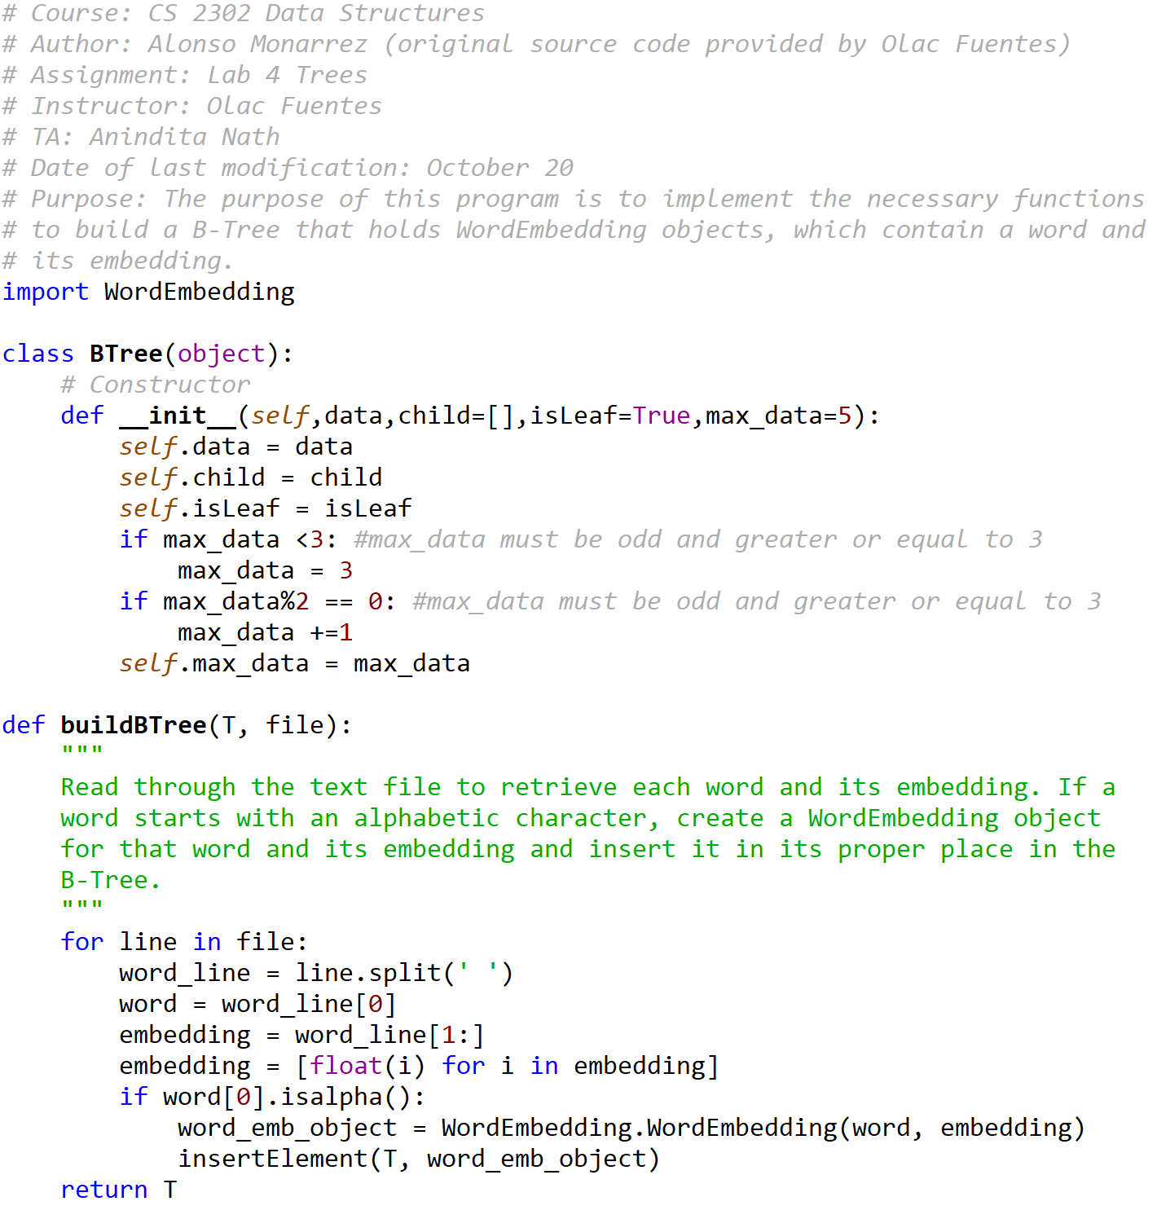

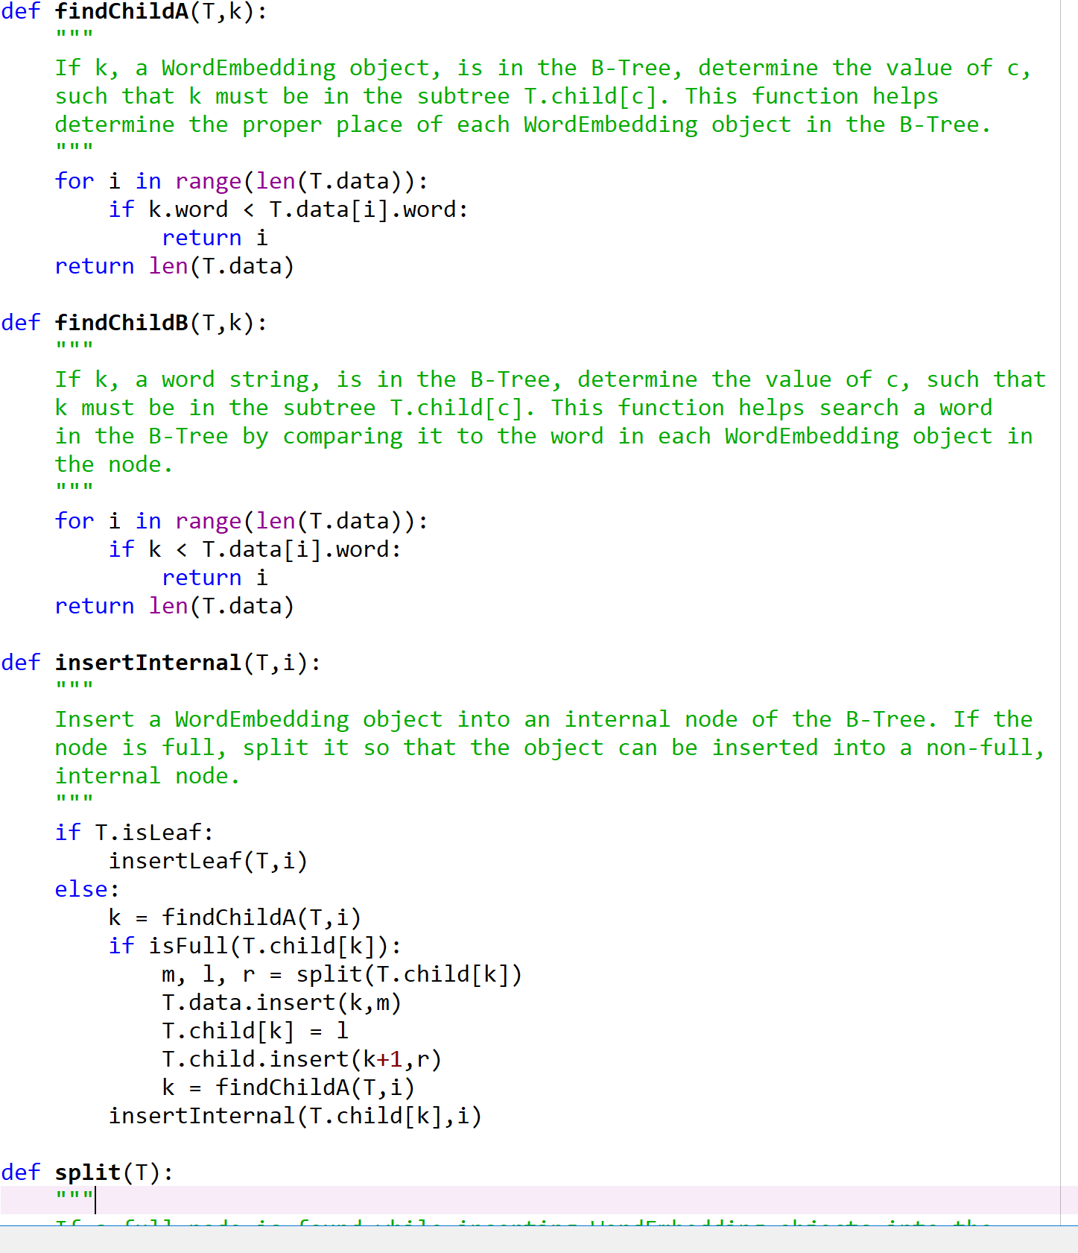



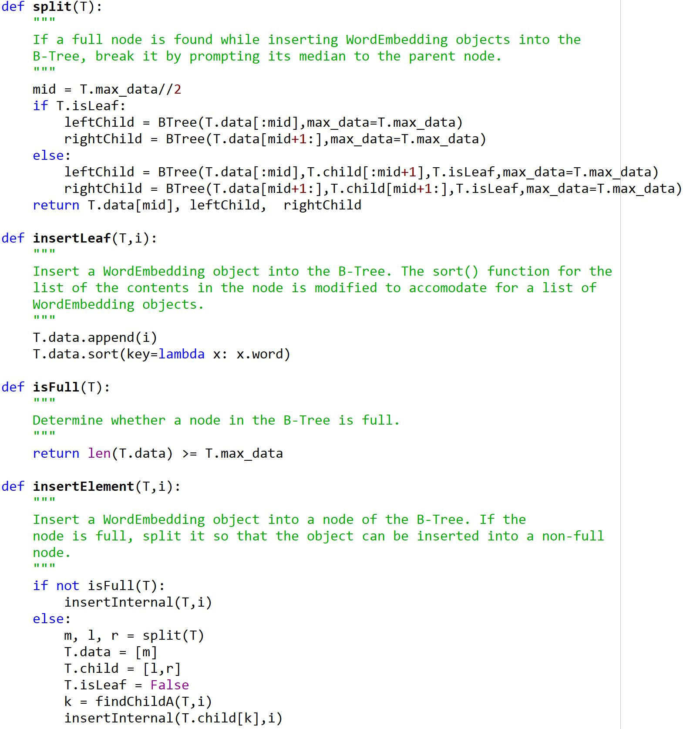

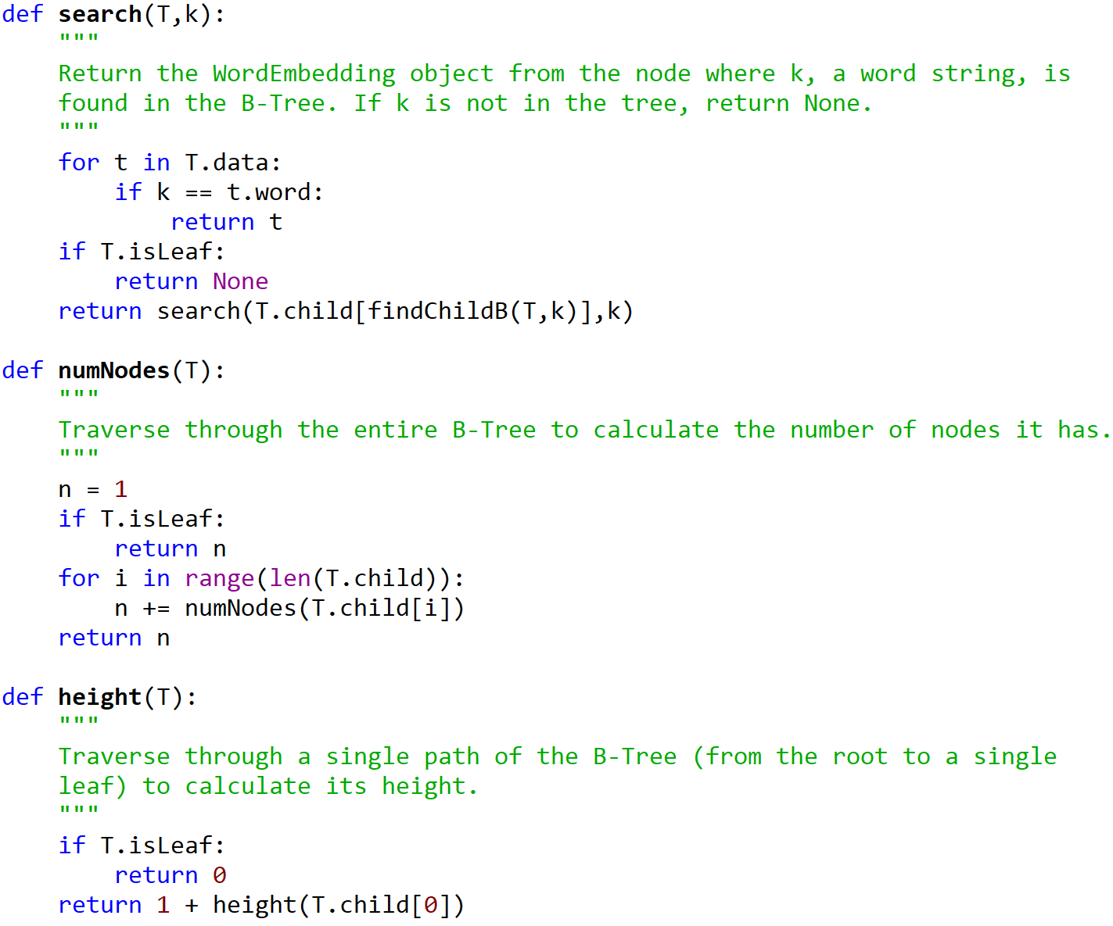

WordEmbedding.py

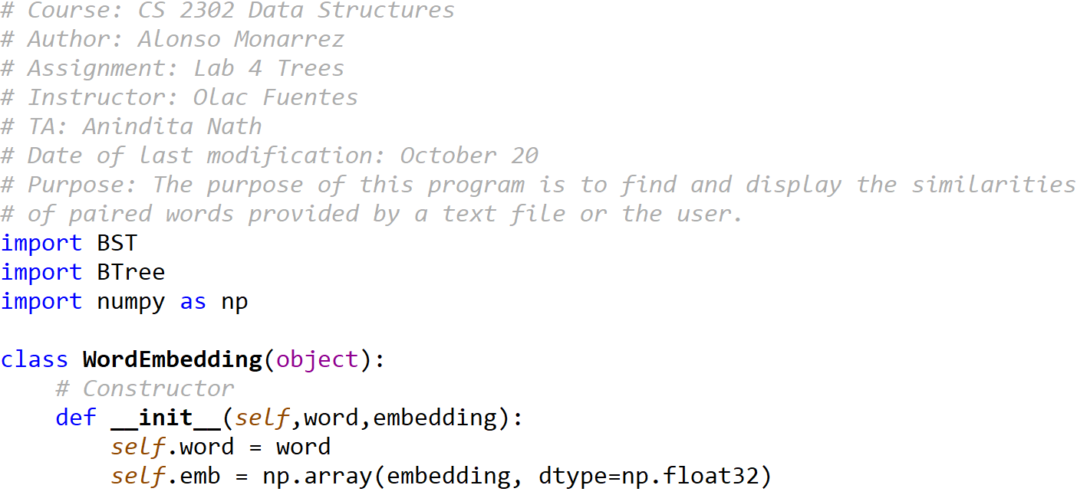



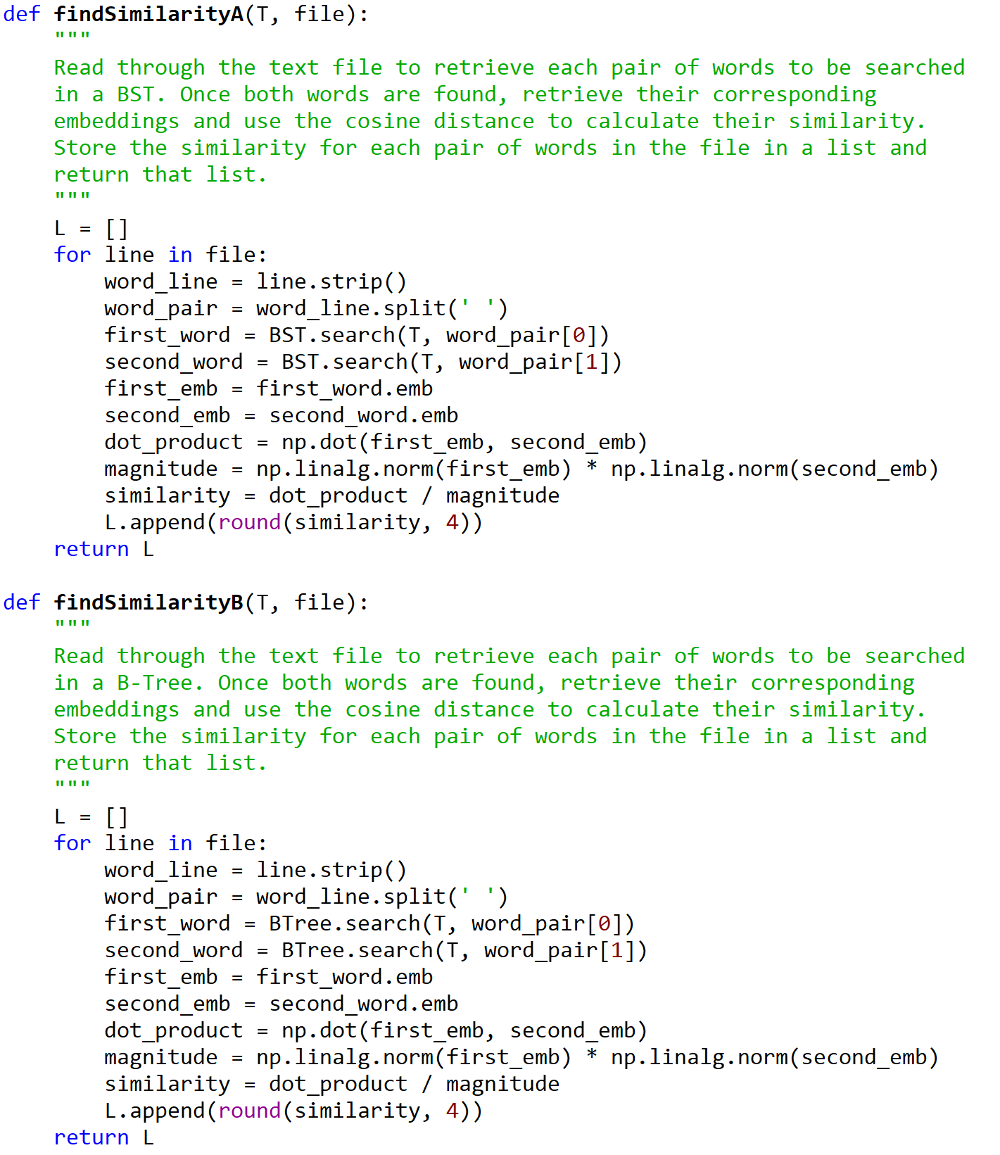

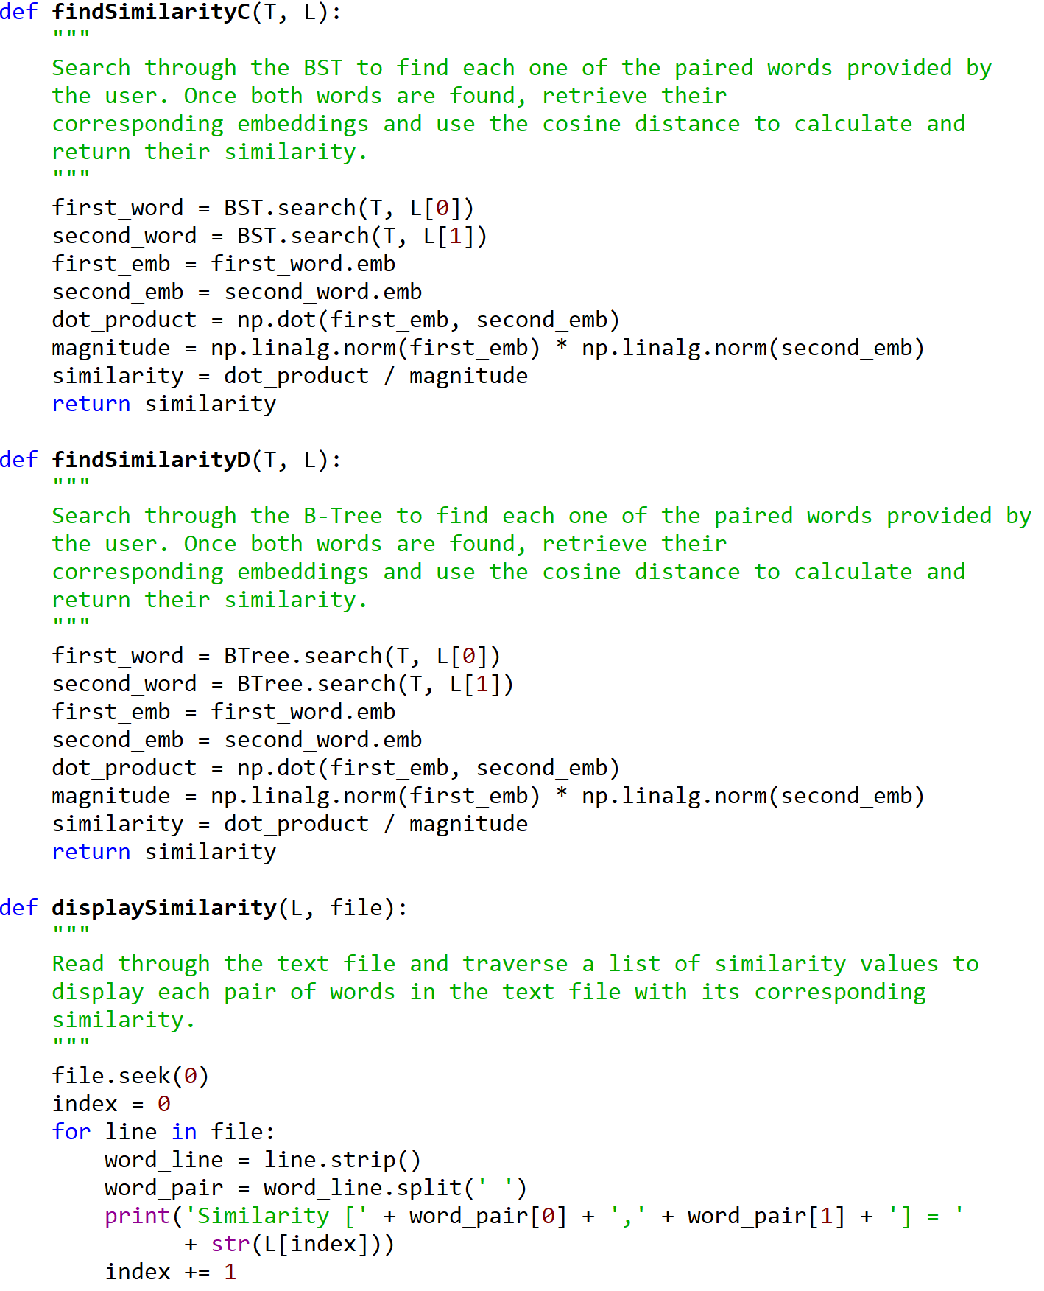

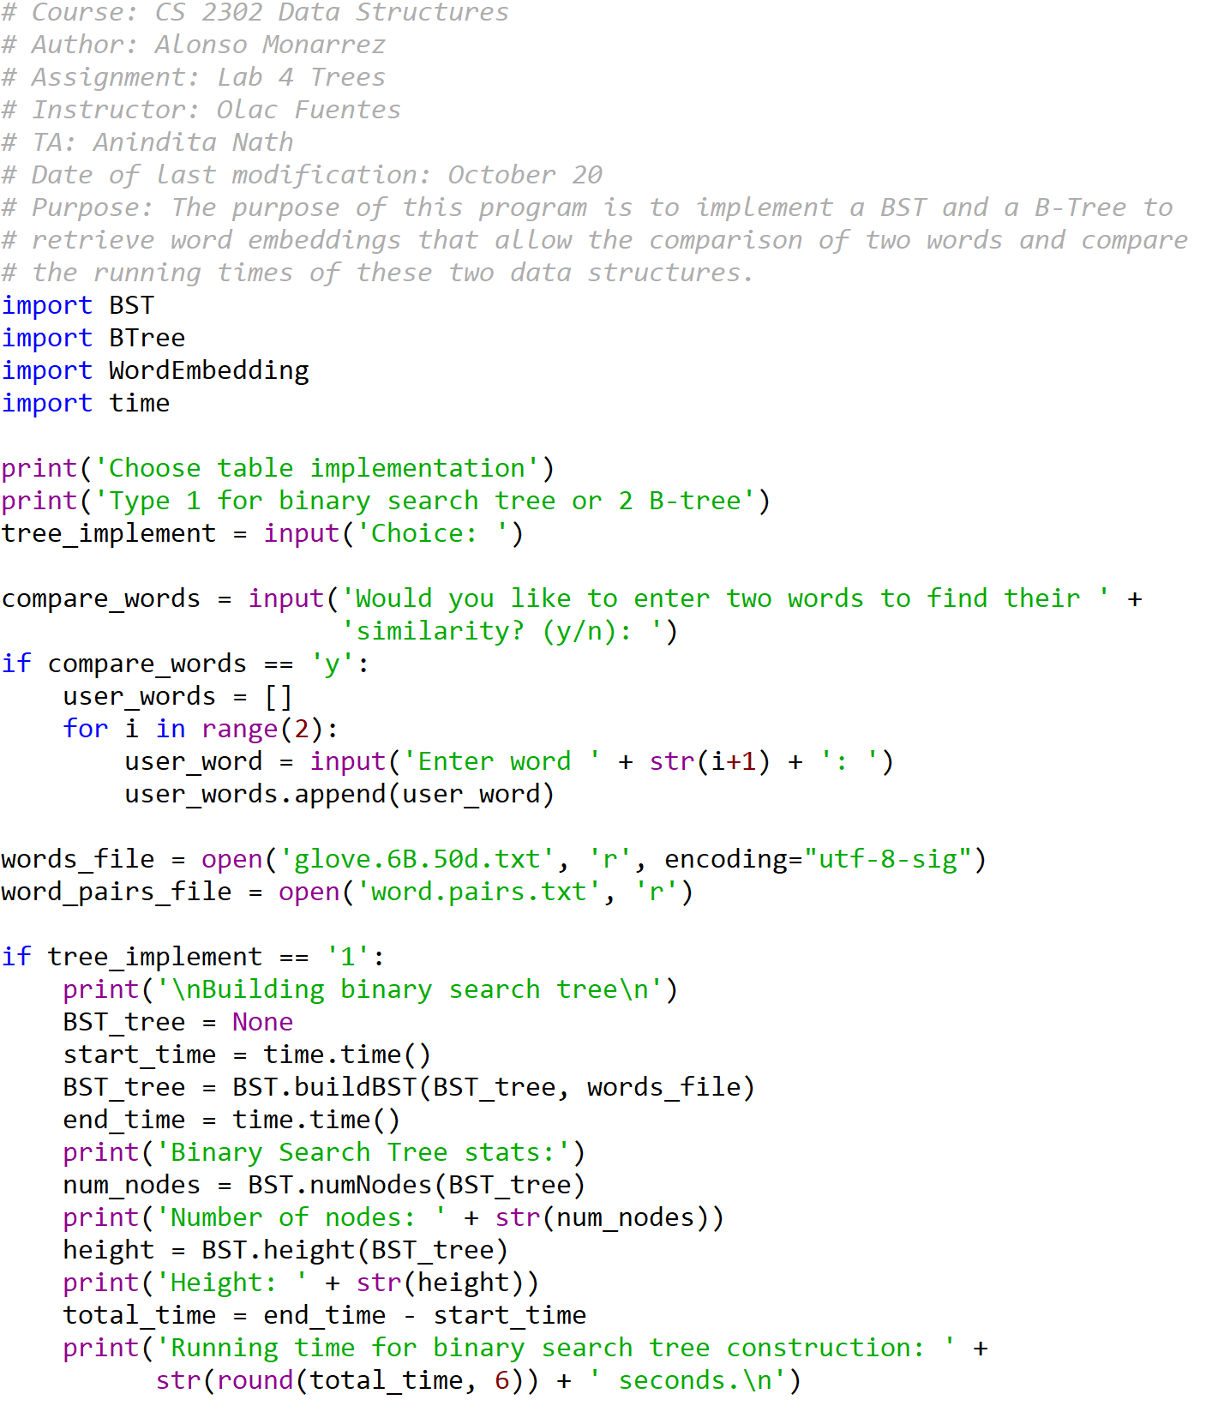

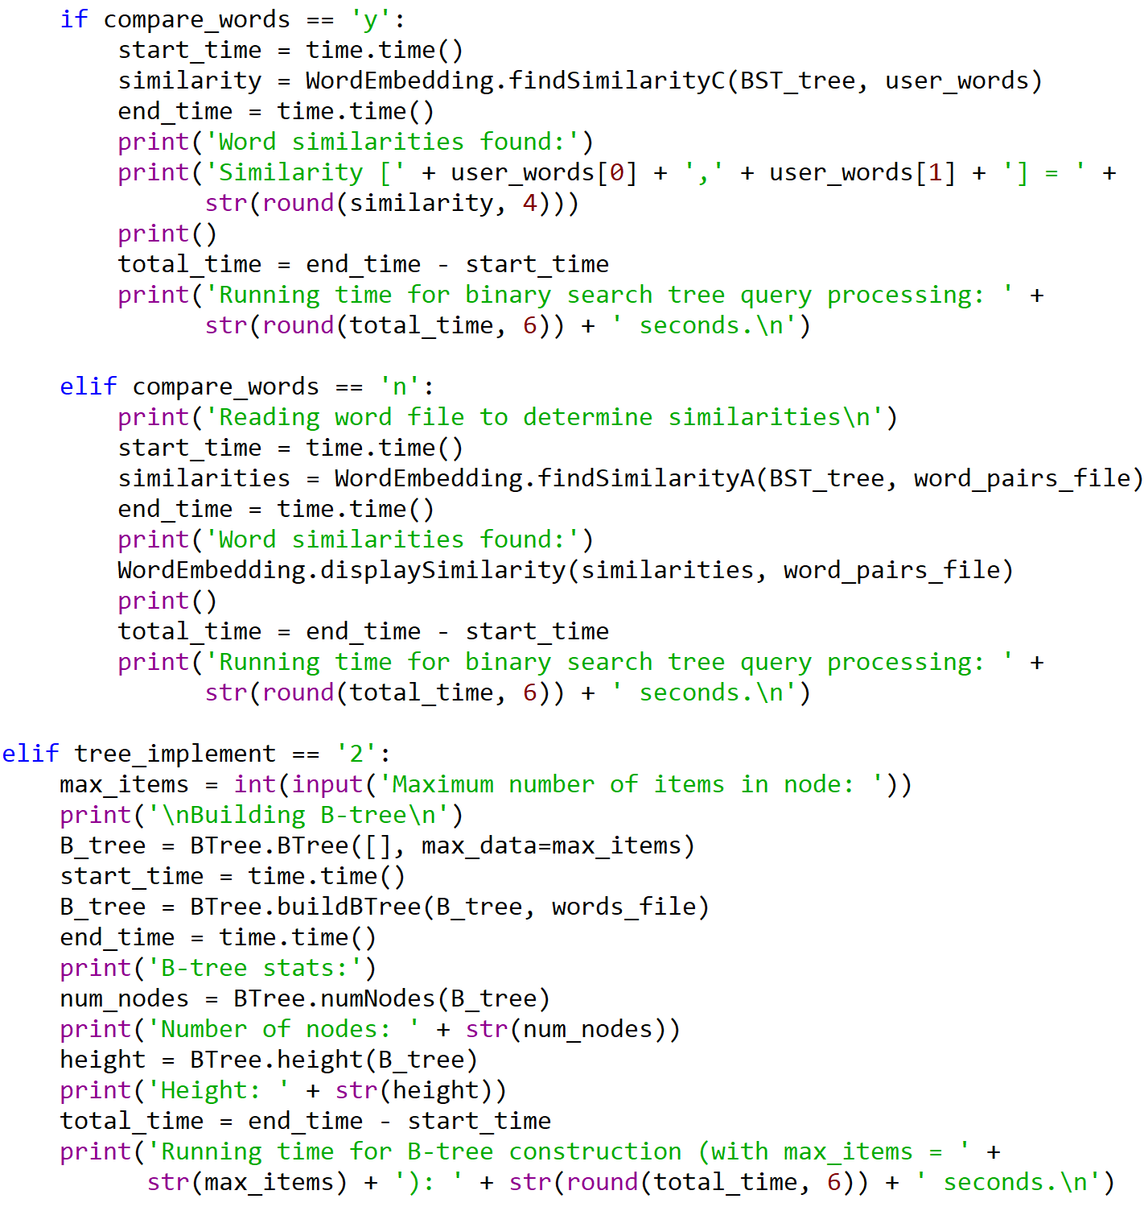

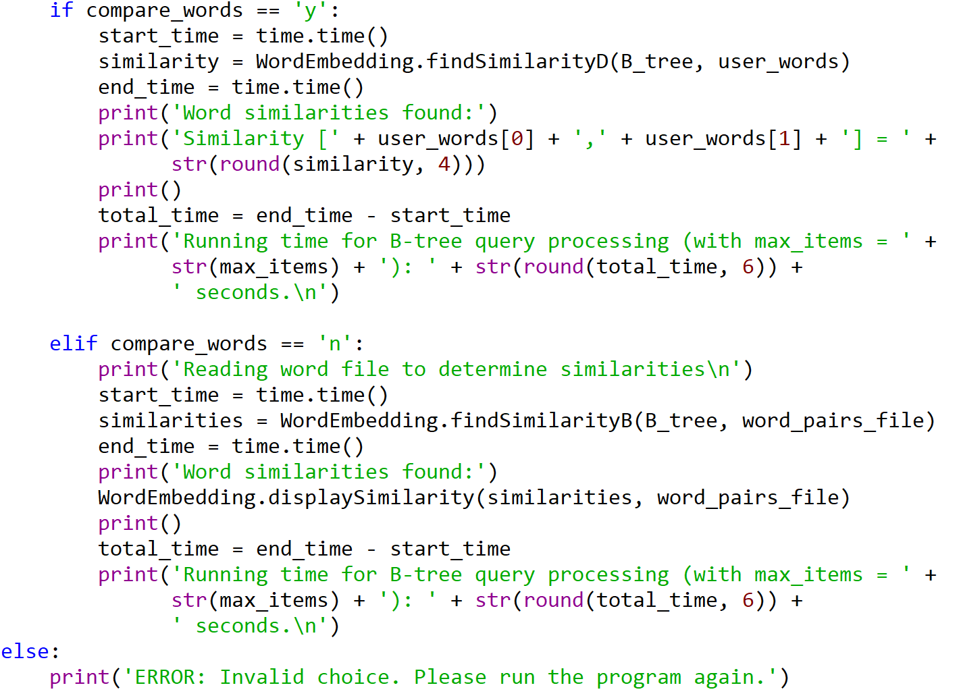

I certify that this project is entirely my own work. I wrote, debugged, and tested the code being presented, performed the experiments, and wrote the report. I also certify that I did not share my code or report or provided inappropriate assistance to any student in the class.